# Appendix 4

# Feedback from Children and Young People

## Where were the respondents from?

There were 636 responses to our online survey. Of those who indicated their home within the Cumberland area the number of responses was as follows:

|  |  |
| --- | --- |
| Whitehaven | 238 |
| Maryport | 49 |
| Workington | 25 |
| Millom | 18 |
| Cleator moor | 14 |
| Carlisle | 13 |
| Dearham | 10 |
| Seascale | 10 |
| Frizington | 8 |
| Flimby | 5 |
| Lowca | 5 |
| Cockermouth | 4 |
| Mirehouse | 4 |
| Moresby | 4 |
| Aspatria | 3 |
| Broughton moor | 3 |
| Egremont | 3 |
| Wigton | 3 |
| Distington | 2 |
| Drigg | 2 |
| Haltwhistle | 2 |
| Haverigg | 2 |
| ravenglass | 2 |
| Seaton | 2 |
| Waberthwaite | 2 |
| Woodhouse | 2 |
| Abbeytown | 1 |
| Baggrow | 1 |
| Beckermet | 1 |
| Bootle | 1 |
| Brampton | 1 |
| Crosby villa | 1 |
| Gosforth | 1 |
| Hensingham | 1 |
| Longtown | 1 |
| Low Moresby | 1 |
| Moor Row | 1 |
| Oughterside | 1 |
| Parton | 1 |
| Wetheral | 1 |
| Whitfield | 1 |

## How do you identify?

Of those who answered this question the results were:

48% female, 46% male, 1% non-binary and transgender. Other responses include “demi-girl", “unsure”, “uncomfortable”

## Q1. What’s it like living in Cumberland

The document provides a diverse range of perspectives from young people on life in Cumberland. Here are the common themes:

* **Outdoor Activities:** Many appreciate the natural beauty and outdoor activities like hiking, biking, and swimming.
* **Limited Entertainment:** A recurring sentiment is the lack of entertainment options, clubs, and places for socializing, leading to feelings of boredom.
* **Community and Safety:** Some value the tight-knit community and consider it a safe place, while others mention issues with drugs and vandalism.
* **Travel and Accessibility:** The rural setting means longer travel times for services and activities, which can be isolating or inconvenient.

Overall, the views on living in Cumberland as a young person are mixed, with some enjoying the tranquility and others wishing for more opportunities and activities.

### Outdoor activities

The document presents a variety of opinions from young people about living in Cumberland. Here's a summary focusing on comments and themes around outdoor activities:

* **Outdoor Enjoyment**: Many young residents appreciate the natural beauty and outdoor activities available, such as hiking, biking, and swimming. They find inspiration in the landscapes and enjoy the tranquility of the countryside.
* **Limited Entertainment**: Despite the scenic environment, there's a sentiment that entertainment options are limited, especially for teenagers. Some feel the need to travel to nearby cities for more diverse experiences.
* **Community and Safety**: The close-knit community and safety are highlighted positively, with many feeling comfortable and content in the area.
* **Mixed Feelings**: While some find the area peaceful and a good place for personal growth, others describe it as boring and lacking in activities for young people.

Relevant quotations include:

* "I love being outdoors, especially because the views bring me inspiration for my art..."
* "It's quite boring as there are not many clubs or places of interest in Brampton for me after school or on weekends."
* "It's a good safe place for children, I want better weather. I really like the landscapes and everything."

### Views on community and safety

The respondents provide a diverse range of perspectives from young people on living in Cumberland. Here’s a detailed analysis of the themes related to community and safety, including relevant quotations:

* **Community Sentiment:** The young residents express mixed feelings about their community. Some appreciate the “quietness” and “beautiful natural surroundings”, while others find it “isolating” and “boring” due to the lack of clubs and activities.
* **Safety Concerns:** Safety is a recurring theme, with some young people feeling “safe” and “comfortable”, while others mention areas that are “scary at time[s]” or have issues with “drunk people and people on drugs”.
* **Desire for Activities:** There’s a strong desire for more activities for young people. Many feel that there is “nothing to do” and that the area could benefit from more recreational facilities and entertainment options.
* **Appreciation for Nature:** Despite the concerns, there is a consistent appreciation for the natural beauty of Cumberland. Phrases like “lovely scenery”, “great for walking”, and the proximity to the Lake District are mentioned positively.

### Views on race and racial integration

The respondents present a collection of personal experiences and opinions from young people living in Cumberland. While the theme of race and racial integration is not explicitly discussed throughout the entire responses there are a few instances where individuals touch upon the subject. Here are some key points related to race mentioned in the document:

* **Diversity and Acceptance:** Some young people mention the diversity in Cumberland and describe it as a place with a variety of cultures and a community that is generally accepting.
* **Challenges Faced:** A few individuals express feeling scared or unsafe at times, particularly one person who mentions feeling a bit scared because they are black, indicating that there may be challenges related to racial integration.
* **Opportunities for Improvement:** The document suggests that while Cumberland has a tight-knit community and beautiful natural surroundings, there is room for improvement in creating more inclusive social environments and activities that cater to all young people, regardless of their race.

Question 2: Where do you go to if you are worried about something? Are there places you feel more comfortable/safe in your local community?

The responses to this question are presented in a word cloud as it not only shows the types of responses, but also the frequency: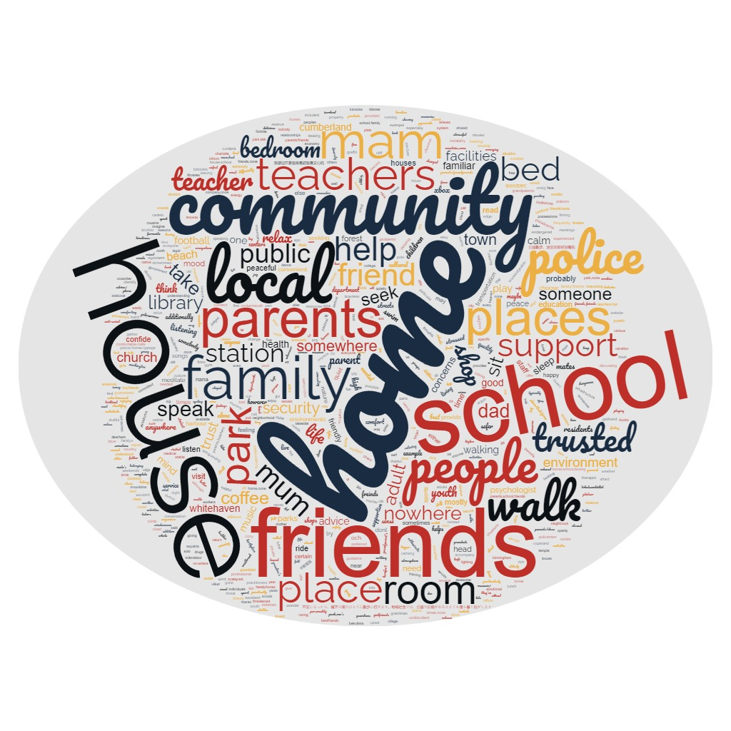

## Q3. Who do you speak with when you have a problem or want to talk about something?

Again this is perhaps best analysed in a word cloud

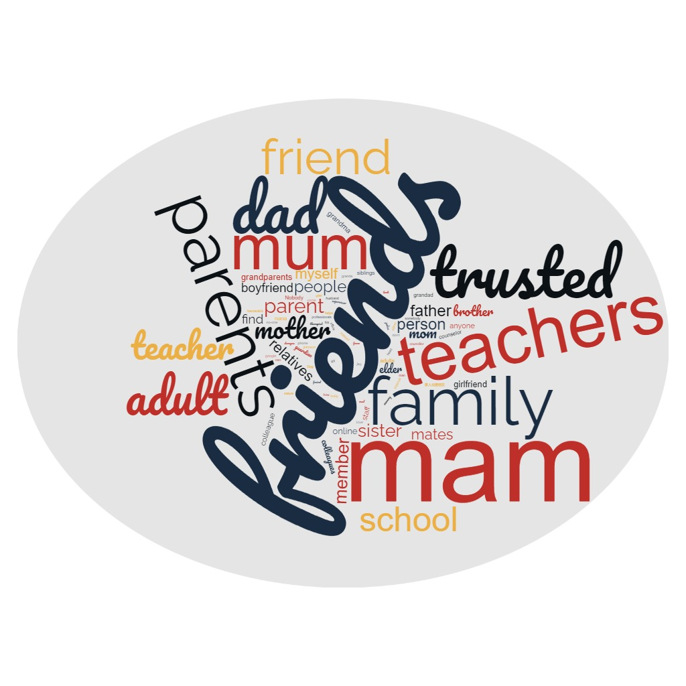

## Q4. What stops you asking for help or support?

A lot of respondents said “nothing” which is encouraging. Of those who provided an alternative answer, the general themes were:

* **Fear of Judgment:** Many express a fear of being judged or perceived negatively by others. For example, concerns about being seen as weak, embarrassment, and the stigma associated with asking for help.
* **Self-Reliance:** A strong desire to handle problems independently is evident. Phrases like “I like to solve problems alone” and “I prefer to not ask for help unless required” highlight this mindset.
* **Social Anxiety:** Social pressures and anxiety play a significant role. Statements such as “Social anxiety” and “Worry of ‘what will they think’” reflect the apprehension felt in social interactions.
* **Introverted Nature:** Introversion is mentioned as a barrier, with individuals stating “my introvert nature” and “I am quite an introvert type” as reasons for their reluctance.

Example responses:

“Shy, scared of what people will say. My secondary school hasn’t dealt with my brothers problems well which puts me off.”

“Fear of being judged or seen as weak- Feeling like I should be able to handle things on my own- Not wanting to burden others- Pride or stubbornness- Believing that I should be able to figure it out on my own. These reasons can lead to a reluctance to seek help, even when it is needed.”

“Feeling that you might get judged for how you feel. When people try to make fun of you without you not realising.”

“Anxiety and worry they might not believe me or understand.”

## Q6. Do you use online platforms to get information and advice?

In answer to this, 67% said yes, and 32% said no.

When those who answered “yes” were asked which platforms they used, they said:

* Snapchat – 28%
* TikTok – 43%
* YouTube – 38%
* Kooth – 9%
* Tumblr – 6%
* Instagram – 27%
* Other – 15%

Of those who answered “other” Google came up frequently, as did Discord and Whatsapp, Facebook and Twitter also appeared.

## Q7. What sorts of things are you worried or concerned about?

General themes from the responses:

* **Concerns About the Future:** Many individuals express worries about their future, including job prospects, financial stability, and personal development. For example, “I’m concerned that I’m never gonna get a job to support myself” and "worried what job i want."
* **Optimism vs. Pessimism:** A noticeable divide exists between those who are optimistic, claiming no worries or concerns, and those who express various anxieties.
* **Health and Well-being:** Concerns about personal health, mental health, and the well-being of family members are frequently mentioned. Quotes like “I am worried about my health and my loved ones health” and “my mental health in this busy city” illustrate this concern.
* **Financial and Economic Issues:** Several responses highlight financial worries, such as the cost of living, job security, and economic conditions. The financial situation is a significant source of stress, with individuals concerned about “my financial situation” and “Not having enough money.”
* **Social and Environmental Issues:** Concerns about the environment, relationships, and community issues are also prevalent. Statements such as “Climate and nature and community living” and “The sanitation of the environment is not very good” reflect these worries.

### Future Uncertainty

* **Future Development:** Many express anxiety about their career and personal growth. For instance, “Worried about one’s future development” is a recurring theme.
* **Financial Stability:** Economic concerns are prevalent, such as “Too many things. Such as economy” and “My financial worries.”
* **Health Concerns:** Health issues are a significant worry, with quotes like "I am worried about my health and my loved ones health.”
* **Social Relations:** Interpersonal relationships and societal pressures are mentioned, like “pressure off school to do well” and “I am always concerned about my mental health and social relations.”
* **Environmental and Global Issues:** Some individuals are concerned about larger-scale issues, as seen in “Climate and nature and community living” and “The Israel and Palestine war along with Russia.”

### Concerns about mental health

* **Mental Health:** Several individuals express worries related to their mental well-being, including anxiety, depression, and the impact of stress on their lives. For example, one person mentions, "I worry a lot about how my future is going to play out… I had to drop out of school due to extremely poor mental health."
* **Emotional Well-being:** Emotional problems are another common concern. Individuals mention feeling not good enough, dealing with the loss of loved ones, and the fear of being alone.
* **Social Relations:** Concerns about social relationships and the impact on mental health are evident. People talk about the stress of school, friend drama, and the pressure to perform well academically.
* **Coping Mechanisms:** Some individuals express a brave front, stating they are not worried because they believe they can handle challenges, which could be a coping mechanism to deal with underlying mental health issues.

These quotations reflect the underlying mental health concerns present in the document, highlighting the need for support and understanding in these areas.

### Financial concerns

The respondents outlined a wide range of personal concerns and worries expressed by individuals. Here’s a detailed analysis focusing on financial concerns:

* **Financial Stability:** Many individuals express anxiety over their economic situation, mentioning worries about “making enough money to spend,” “my deposit,” and the “financial situation in my community.”
* **Future Prospects:** Concerns about future job security and the ability to “support myself” or “afford to live” if they move away are prevalent. The “cost of living crisis” and “salary insecurity” are also highlighted.
* **Personal Finance:** Some individuals are specifically worried about their “financial conditions,” with mentions of “not having enough money” and the pressure of “school to do well.”
* **Economic Impact:** The broader economic issues are also a concern, with references to the “economy,” “financial problem to survive in this city,” and the “financial worries” affecting family and personal life.

### Social relations

The theme of social relations is evident in several responses, where people express worries about interpersonal relationships, friendship issues, and the impact of social dynamics on mental health. Here are some key points:

* **Interpersonal Concerns:** Individuals mention worries related to interpersonal relationships and friendship issues, highlighting the importance of social connections in their lives.
* **Mental Health:** Concerns about mental health are linked to social relations, with mentions of bullying, social anxiety, and the need for support in tough times.
* **Support Systems:** The value of having a support system, whether it’s friends, family, or school, is emphasized, especially when dealing with personal challenges.
* **Social Dynamics:** The impact of social dynamics on individuals’ well-being is a recurring theme, with worries about fitting in, being judged, and maintaining friendships.

These points reflect the complex nature of social relations and their significant impact on individuals’ lives. The document provides a rich source of quotations that illustrate these themes, such as concerns about “friendship issues,” the desire for “support,” and the challenges of “being judged” by others.

### Social and environmental concerns

The respondents touch on various social and environmental concerns that individuals have:

* **Personal Worries:** Many individuals express concerns about their future, including career development, financial stability, and personal relationships. Quotes like “I worry that I’m not making enough money to spend” and “worried what job I want” highlight these anxieties.
* **Health and Well-being:** Health issues are a recurring theme, with worries about personal health conditions, mental health, and the health of family members. Statements such as “I’m also worried about my health condition getting in the way of my future job” and “I am worried about my health and my loved ones health” reflect this concern.
* **Environmental Concerns:** Some individuals express worries about climate change, the cost of living, and the state of their community’s environment. Phrases like “Climate and nature and community living” indicate environmental awareness.
* **Optimism vs. Pessimism:** The responses also reveal a contrast between optimism and pessimism. Some individuals claim not to be worried about anything, showing a brave or optimistic outlook, while others express a wide range of concerns, indicating a more pessimistic view of the future.

## Q8. What support could be offered to make a difference to you and help you in the future?

There are a variety of responses from individuals regarding the support they would like to receive to make a difference in their lives. Here are some general themes:

* **Educational Support:** Many individuals express a desire for more knowledge, educational resources, and better teaching to help them in their academic and professional pursuits.
* **Emotional and Mental Support:** There is a significant emphasis on the need for emotional support, mental health resources, and counselling to navigate personal challenges.
* **Financial Assistance:** A recurring theme is the need for financial support, including help with managing money, job opportunities, and financial aid for various purposes.
* **Social and Community Support:** Responses highlight the importance of social connections, community activities, and accessible places for interaction and support.

These themes reflect a broad range of support needs that can contribute to individuals’ well-being and future success.

### Educational support

The theme of educational support is prominent, with many respondents expressing a desire for more knowledge, better education, and specific learning support. Here are some key points and relevant quotations:

* **Educational Needs:** Respondents express a need for “Better support in schools” and "more help in classes for my ADHD and autism."
* **Mentorship & Guidance:** There’s a call for “mentorship or coaching to develop my skills and knowledge” and "guidance from experienced professionals in my field."
* **Emotional & Social Support:** Many seek “emotional support and some faith in my work” and "a safe space to meet with friends and get advice."
* **Financial Assistance:** A common thread is the need for financial support, as seen in “Financial support would make a difference in my life” and "scholarships, grants, or low-interest loans."
* **Online Learning:** Respondents express a desire for more knowledge and continuous technical upgrades, including improvements in natural language processing and domain knowledge.
* **Educational Support:** There’s a call for better support in schools, more fun local places, and clubs to interact with peers: “Better support in schools, more fun local places and clubs to interact with others my age…”
* **Skill Development:** Social skills classes and support groups are suggested to help individuals, particularly those who are neurodivergent, to transition into the workforce successfully: "Learning vital social skills can make the difference between being unable to work and having a fruitful career."
* **Access to Resources:** Respondents seek more accessible places to talk about mental health, financial assistance, and guidance on managing money and planning work: "There could be more accessible place to talk about mental health… More ways to manage money… work planning…"

These responses highlight the importance of educational support, skill development, and access to resources as key factors in helping individuals prepare for their future.

These responses also highlight the multifaceted nature of support that individuals seek, encompassing educational, emotional, social, and financial aspects.

### Emotional and mental support

The theme of emotional and mental support is prominent throughout the document, with many respondents highlighting the need for:

* **Emotional Support:** Respondents express a desire for solidarity, blessings, and someone to believe in their decisions. Quotes like “emotional support would be helpful”. “I need someone who can believe in me” and “just some blessings from my loved ones” underscore the importance of emotional backing in times of need.
* **Mental Support:** The need for mental support is evident, with mentions of “mental support from my family in times of need” and “therapy” indicating a recognition of the value of mental health services.
* **Financial and Physical Help:** Beyond emotional and mental support, there is a call for more tangible assistance such as “mostly financial support and physical help” and “financial support would make a difference in my life.”
* **Social and Professional Assistance:** Some responses point to a need for social inclusion and professional development, such as “more help in looking for a job” and “better career development.”
* **Mental Health:** Responses highlight the need for mental health support, including therapy, counselling, and safe spaces to discuss personal challenges. One individual states, “Therapy” as a form of support they would appreciate.
* **Social Connections**: Building relationships and having a supportive network of friends, family, or community members is seen as crucial for reducing stress and building resilience4. A response emphasizes this by saying, “Building relationships with family, friends, colleagues or other community members…can help reduce stress and build resilience to frustration.”
* **Self-Care Awareness:** Some responses indicate a need for better self-care awareness, focusing on physical and mental health through diet, exercise, sleep, and maintaining a good mental state. A relevant quote is, "Learn to listen to your own needs, focus on physical and mental health…"

These responses reflect a common understanding of the importance of emotional and mental support in individuals’ lives.

These quotations also reflect a common human desire for a support system that encompasses emotional, mental, financial, and social aspects, highlighting the multifaceted nature of well-being.

### Financial assistance

The theme of financial assistance is recurrent, with many expressing a desire for monetary support to help with various aspects of life. Here are some key points and relevant quotations:

* **Financial Support:** Individuals frequently mention the need for financial assistance, which could help them manage money better, support educational pursuits, or provide stability. For example, one quote states, "Financial support would make a difference in my life as I love donations and if offered I would donate to the needy ones."
* **Emotional and Mental Support:** Alongside financial aid, there’s a strong emphasis on the importance of emotional and mental support. Quotes like “emotional support would be helpful. solidarity in times of need” highlight the need for compassion and understanding.
* **Educational and Professional Growth**: Support in education and career development is also a common theme. Individuals seek better education, job opportunities, and professional guidance, as seen in the quote, "Better support in schools, more fun local places and clubs to interact with others my age."
* **Financial Support:** Many responses highlight the importance of financial aid, indicating a common need for monetary help. For instance, one individual mentions, “Money and help in life,” while another seeks “more ways to manage money.”
* **Educational and Career Aid:** Some responses connect financial support with educational and career opportunities, suggesting that financial aid could help them pursue further education or find suitable jobs, especially for those with health conditions.
* **Emotional and Social Support**: While discussing financial assistance, several responses also touch upon the need for emotional and social support, indicating that financial stability is often intertwined with overall well-being.
* **Desire for Independence**: A few responses express a desire for self-sufficiency, with statements like “I can do it myself” reflecting a preference for independence over financial assistance.

These insights reveal a multifaceted view of financial assistance, where individuals seek not only monetary support but also the tools and opportunities to achieve self-reliance and emotional stability.

These points reflect a collective desire for a support system that addresses financial, emotional, educational, and health-related needs.

### Social and community support

The document contains a variety of responses regarding social and community support. Here’s a detailed analysis:

* **Online Communication:** Many individuals express a desire for more online interaction, suggesting a need for digital platforms for support and engagement.
* **Knowledge and Education:** Respondents highlight the importance of continuous learning and access to information as a form of support.
* **Financial and Practical Aid:** There’s a recurring theme of financial support and practical help in life, indicating that economic stability is a significant concern.
* **Emotional and Mental Support:** Emotional solidarity, mental support, and having someone to believe in one’s decisions are mentioned as crucial forms of support.
* **Health and Well-being:** The need for better healthcare, stress management, and a healthy environment is emphasized, reflecting concerns about physical and mental health.

Relevant quotations include:

* "Money and help in life gave me the confidence to have more friends around me to talk to."
* "Building relationships with family, friends, colleagues or other community members… can help reduce stress and build resilience to frustration."
* "I need someone who can believe in me and my decision."
* "It’s so good to know when in times of need we will be supported by our neighbours as they will be the first one to reach."

These responses suggest that a multifaceted approach to support, encompassing financial, educational, emotional, and health-related aspects, is essential for community well-being.