
Being a Child in Cumberland: What we should focus on and what we should change
Date: July 2023
Author: Joel Rasbash, Strategic Policy and Scrutiny Advisor, Policy and Scrutiny Team
Audience: SLT

Contents

Appendix 1: Sufficiency: High numbers of cared for children p.2
Appendix 2: Sufficiency: SEND and the High Needs Block p.11
Appendix 3: Home to School and SEND Transport Pressures p.17
Appendix 4: Levels of Educational Attainment p.21
Appendix 5: Health Inequalities p.27
Appendix 6: National and Government Policy for Children p.31
Appendix 6: Feedback from Regulators (Ofsted and Ofsted/CQC) p.37

Appendix 1: Sufficiency: High numbers of cared for children

What is the issue?
For Children’s Social Care sufficiency and the pressures of increasing demand on the scope for prevention work is a significant challenge. For children this means:
- Higher than national average numbers of children cared for;
- Children spending longer in care on average (over 3 years on average);
- Children aged 10-16 and boys are more likely to be in care than the national average;
- A significant number of children being homed over 20 miles from their home or out county;
- A high number of children at the edge of care.

The following strengths are important in assessing the issue:
- Cumberland inherits a recent Ofsted ILACS inspection that rates the experience of children cared for and care experience as Good. This is a significant strength to build on as it means the right children are being supported in our care and they are getting the right support in our care, they are safe, and their voice is being listened to;
- The service has moved towards a strength-based approach to social work practice which has made significant inroads into changing the culture of social work (as picked up in the Ofsted inspection report which identified improvements in staff moral compared to previous inspections);
- The service has been recently been successful in a number of bids for national improvement money, which informs the opportunities section below.

N.B. The service experiences significant workforce recruitment challenges that are out of the scope of this paper which requires a parallel piece of policy work – and which will be critical to the opportunities outlined below

What is the evidence?
Evidence from March 2023 shows that:
- Cumberland has higher rates of children in need, on a protection plan and children cared for compared to the national average and statistical neighbours;
- The disparity increases with each stage of stage of increased intervention – so the rate of children in need is close to the national average while the rate of children in our care is 32.9% higher than the national average;
- Rates in Allerdale and Copeland are significantly higher than Carlisle (with Carlisle’s rates of children known to social care below the national average).

Table: Rate per 10,000 of Social Care provision (Mar 23)
 | National | Cumberland
Rate (per 10,000) of Children in Need | 321 | 332
Rate (per 10,000) of Children with a Child Protection Plan | 42 | 52
Rate (per 10,000) of children cared for with the Local Authority | 70 | 93

Table: Rate per 10,000 of Social Care provision by District (Mar 23)
 | National (20/21) | Copeland | Allerdale | Carlisle
Cases open to children cared for | 321.0 | 326.8 | 327.4 | 287.4
Children subject to Child Protection Plan | n/a | 98.1 | 69.8 | 66.5
Children in care - number and rate | 41.0 | 55.3 | 58.2 | 49.8

On 31 December 2022 Children in the Cumbria area were spending on average 1047 days in our care compared to 908 days nationally. This has risen from 860 days in 2017/18, a rise of 22%. Specifically for children aged 10-15 years, the length of time they spend in our care in the Cumbria area has risen from 408 days on average in 2017/18 to 714 days in January 2022: a 75% increase.
Children cared for rates are strongly linked to deprivation. Almost of a third of all Cumberland’s children cared for come from the area’s 18 LSOAs that rank within the 10% most deprived in England – Allerdale (7), Copeland (6) and Carlisle (5).
In terms of costs, over the last 5 years for the Cumbria area:
- £14.9m average annual spend on external residential and care with each child costing an average of £189k per annum.
- £7.7, average annual spend on Independent Fostering Agencies (IFAs), with each child costing an average of £41,912 per annum.

NB: Given the numbers of children in homes that cut across the Cumberland and Westmorland border, it makes sense to continue to monitor these costs across the Cumbria area, while focusing on Cumberland’s specific costs).

Potential savings that could fund prevention include:
- 50% reduction for every child that is brought from an Independent Fostering Agency into in-house foster care;
- £75k on average per child per annum if brought back into in-house children’s homes.
- A 5% reduction in children in our care in out of area homes would see a cost saving of £5.3m over 5 years based on current average costs.

What are the opportunities?
There are three main opportunities that are currently being developed that could be scaled up.
- Developing a preventative model based on interdependence and community networks;
- Developing programmes that target particular groups more likely to go into care, specifically teenage boys and children aged 0-2;
- Placing social care professions within school setting.
These would require investment and further modelling would be needed to look at invest to save options.
From Independence to Interdependence: The Independence Model focuses on supporting children where there is statutory intervention to become independent adults and manage on their own (with care experience often being literally the case). The model focuses on the presenting problem rather than looking at what drives intervention.
The Interdependence Model focuses on enabling children at risk of statutory intervention have loving trusting relationships (it could be with family, siblings, wider kinship network, neighbours or professionals).
Bright Spots is a national research report with Care Experienced young people which found that young people at least one person who loves them and sticks to them. They have identified the following public health outcomes from moving adopting an interdependence approach:
- Reduced loneliness
- Better mental health and well being
- Stronger community connections.
Lag measures that could be monitored include - increasing trust in social workers, increasing retention of social workers.
Whereas the Independence Model focuses on the 2-3000 children known to Social Services, the Interdependence Model can be extended to include the Council’s wider Public Health and Community Development activity and give a greater role for Councillors.
Opportunities include:
- Utilising Cumberland’s position as a recipient of Transformation Funding for the Family Hubs to implement a 0-19 approach to using community-based approaches to building trusting relations, including a stronger youth work offer, and utilise the learning in reviewing the 0-19 contracts before they expire in April 2024.
- Extend the work of the Safe Families initiative that was adopted in West Cumbria in 2018, to recruit more community volunteers who can offer respite stays for children up to 28 days, befriend families in need of support and to partner with families as ‘resource friends’ who can help with finance and other material support needs.
- Strengthen the use of Special Guardianship Orders so that children are cared for within their wider family network (thus building trust from the start and contributing to more children care for close to home).
- Strengthen the link between social work teams and the Council’s wider community support offer, i.e., the Household Support Fund, community grants etc. by reviewing processes and practices that leads to intervention when a simpler solution is available.
- Support the initial work of the Virtual School down the age range to include Early Years children within nursery provision
Strength-based practice: Signs of Safety has been a successful practice methodology that has successfully worked with families referred to children’s social care by concentrating on the strengths of the whole family network. There is significant scope to extend it as a practice method by:
- Approaching the first day of a child’s removal as the first day of their potential reunification, and building strength-based family contact and reunification into the child’s permanence plan;
- Creating a Safeguarding Practice Review Board for all cases prior to being presented at Legal Gateway Process to ensure the right cases are being brought at the right time, and that the family and network have been given every opportunity to come up with and apply their own solutions;
- Staying fully engaged with the family and network through care planning reviews that will include everyone who is connected to the child in the assessment, planning and support of the child or young person and the home they are living in.
Targeted approaches to reduce the number of children cared for by the Council: Two key drivers of the levels of cared for children is a) the number of teenage boys who are entering the system and b) children aged 0-2. Opportunities exist to address these drivers including:
- Adopting the No Wrong Door Approach pioneered by North Yorkshire Council. This works with a target group of children aged 10-16 who are designated ‘edge of care’ by providing a multi-agency support service that is delivered in a single location. It uses an interdependence approach by building a team of social workers, police, youth workers and other professionals who get to know the child and work intensively with them and their families.
- Considering the development of a Pre-Birth service based on models in the North-East. Sunderland has a dedicated team that accepts referrals from conception (rather than from 16 weeks into pregnancy) and from any woman has had previously had a baby removed. They focus on preventing the baby from being removed, and planning for adoption (rather than fostering) when a baby is to be removed, so the child has a permanent attachment from birth. The service involves a 10-day assessment and has agreed a policy with the NHS of not removing a baby from its mother to a Neo-natal ward unless there is specific medical reason.
- Extending the current remit of the Pause Programme which provides intensive 1-1 and group support for mothers who have had two or more babies taken into care, and potentially linking it with a Pre-birth service.
Specialist support within schools: Schools are often key to detecting the early signs of neglect, abuse and other safeguarding factors which result in statutory intervention. Cumberland has benefitted from pilot funding for two programmes that used professional placement within the school to strengthen the support children and families at risk of statutory intervention receive within the school. These opportunities include:
- Rolling out the Reflective Safeguarding Supervision programme across all schools. The pilot finishes this year and involves a trained social worker providing reflective supervision to school safeguarding leads. Case studies have demonstrated the impact, particularly in relation to adolescent mental health challenges.
- Developing a programme of school based Early Help workers and community connectors, who can support pupils and their families directly with Early Help interventions, by supporting them within the school community, connecting them with wider community support and providing a liaison point with statutory Children’s Services for more complex situations. Evaluation of the Children Social Worker in Schools pilot, shows the model working in one secondary school in an area with high levels of deprivation, but also that the role needed is not a trained social worker, but someone who can work preventatively before issues escalate.
Each of the interventions below set out existing and potential programmes that could help tackle the lag indicators of too many children in care, and spending too long in care, by focusing on what could be potentially implemented in year 1 of Cumberland.
More detail on existing programmes linked to these opportunities
Early Help
Cumberland inherits an Early Help Strategy that was developed by the Cumbria Children’s Trust Board in 2020 with a focus on wrap-around support to schools, however Ofsted in 2022 identified that the approach and quality of EH referrals is an area that requires improvement.
DfE Family Hub Transformation Fund: Cumberland is one of 12 Local Authorities successful in bidding for the fund which will lead to a Family Hub being set up in April 2024, which will provide a universal multi-agency ‘front door’ for family-based working. The Hub will consist of a single physical centre, outreach facilities across Cumberland and a digital offer (with further Hub development as the national role out of Family Hubs is implemented).
Pause: Pause works with women who have had more than one baby taken into care. Each Pause practitioner provides intensive trauma informed support to 8 women. Since 2017 Pause has worked with 73 women who have had 240 children taken into care. In November 2022 it was estimated that a scaled-up version for Cumberland and Westmorland/Furness could potentially work with up to 287 women with 764 children who will be taken into care. There is a potential to model the cost/benefits of extending Pause to all women who have had one child removed.
DfE Social Workers in Schools pilot: Cumberland is one of a group of Local Authorities piloting the Social Workers in Schools programme. This has a social worker placed within the school who can advise the school, support with safeguarding, prevention and Social Work interventions, and has a caseload of pupils. The programme will be ending in June 2023. Key local learning from the programme include:
- The added value of having a trained professional within the school setting who can work directly with children in the school and their families without going through the usual social work referral procedures;
- The work has been preventative and could be easily delivered by having Early Help workers placed within schools, rather than qualified social workers;
- The model is ideal for working with the 10-16 year old cohort of children who are below the threshold of Children in Need and Child Protection, but could potentially fall into those categories.
DfE Reflective Supervision in Schools pilot: 51 schools are taking part in a Reflective Safeguarding supervisions programme supported by 2 Social Work Qualified Advanced Practitioners. Priorities for Primary Schools are parental alcohol, substance misuse and Mental Health, and priorities for Secondary Schools are child exploitation, persistent non-attendance and child mental health. Comparisons between schools taking part and a control group show a 5% increase in appropriate safeguarding referrals and 20% increase in Early Help support. The pilot is funded until August 2023 and at present it is not clear whether there will be future funding.
Edge of Care: No Wrong Door (NWD) is a multi-agency hub model that was developed in North Yorkshire to provide support to young people living at the Edge of Care. The target population to work with through NWD are:
- Young people living in external residential homes aged between 10-17 years where their potential is not being met (ages 10-15 years will be the initial focus)
- Young people living in foster-care with someone from an Independent Fostering Agency (IFA) who do not have a long-term foster/adoption match.
It provides:
- Short term place to stay
- Edge of care support (in and out of care)
- A range of services, support, and accommodation options
- Embedded specialist roles based in the Hub
- Integrated team ‘sticks with’ young people on their journey

In the first 5 years of implementing NWD in North Yorkshire, the following benefits were evidenced for the young people supported:
- Children going missing episodes reduced by 87% (68% in year 1);
- 81% young people supported do not become children in care;
- 98.% of emergency referrals do not end up as children in care;
- All residential care is in county and all foster caring is in-house;
- 50% reduction in arrests;
- 69% reduction in permanent school exclusions.
In terms of cost savings, NYCC benefited from a net saving of £50,000 in year 1, and in 2021, 5 years later, these savings had increased to £2.65 million. Positive results to the use of NWD have also been seen in Rochdale, where the use of IFA’s reduced by 20% in the first year, residential homes by 13% and semi-supported accommodation by 37%.
Adopting No Wrong Door in Cumberland would cost £1.5 per annum, and its first priority potentially could be to work with Cumberland’s share of the 49 young people from Cumbria aged 12-16 years who are in external residential provision and without a permanency plan of residential care or any additional needs.
Community and Kinship Care
Kinship care is where children are brought up by members of their extended families, friends or other people who are connected with them. Kinship care is a way to prevent a child being taken into care, and if so, to be cared for by someone the child already loves and trusts.
Kinship arrangements can be temporary or permanent and can be made by the local authority or directly within the family network. By using Family Group Conferencing early, it is possible to put kindship care arrangements in place before problems escalate.
Common reasons for children being in kinship care include parental drug or alcohol abuse, neglect, domestic violence or the death of a parent.
The various kinship arrangements include:
- Arrangements made within the family only. The length of the arrangement is decided by the person with parental responsibility or someone who has taken out a legal order to care for the child;
- Private fostering, where the parent/carer makes the arrangement. The carer is not a close family member. If the arrangement lasts for 28 days or more, it needs to be approved by the local authority;
- Child arrangement order and Special Guardianship Order, is where a child is legally placed family member, friend or non-related foster carer.
More informal types of support can include utilising friend and family networks to provide temporary respite care enable the child and parents to have a break.
National cost benefit analysis commissioned by the organisation Grandparents Plus calculated that 6.75% of children in care are in Kinship Care arrangements and evaluated the financial savings to local authorities if they increased this and identified the following improvements in outcomes for the child: better GCSE passes and NEET reductions, improvement emotional and physical health and reduced offending.
These findings are also underscored by the Nuffield Trust’s study of Special Guardianship Orders.
In Cumberland there are several programmes that would support this approach including Pause, Safe Families and Project Connect.
Safe Families is a Christian faith-based organisation the provides support services across 35 local authority areas including Cumberland and Westmorland. They provide three main support services:
- Recruiting volunteers to befriend families with an initial 12 week pairing of a volunteer and the family with the aim of becoming lifelong friends;
- Hosted Families – hosting a child with a family for up to 28 days (which is the threshold where a child is taken into care), for instance, if a parent is in hospital or where there is risk of family breakdown;
- Recruiting ‘resource friends’ – people who are introduced to a family and provide them material resource, i.e., (money for bills, presents, days out etc.) transporting, help around the house etc.
Nationally they have a network of 1500 volunteers and take a local community approach in building volunteer networks.
Lag and Lead Indicators
This section opens up some ideas for lag and lead indicators. Further work would be needed with the service to refine these and into indicators that could be broken down to operational team level, so the whole service is working to them.
Ideas for Lag Indicators
- Reductions in the rate of cared for children, Children on a Child Protection Plan and Children in Need:
- Reductions in numbers of boys and children aged 10-16 for the above;
- Reduction in average time spent in in care (NB. this has risen by 22% (2017-2022) and by 75% for children aged 10-15).
- Reductions in all of the above from Cumberland’s 18 LSOAs ranking the 10% most deprived nationally (currently 30% of children in cre come from these areas)
- Reduction in children being placed in an out of county home (from 28.7% for Cumbria’s children (2021-22) were placed out of county which is higher than the national average and statistical neighbours).
- Reduction in annual spend on external residential care (currently £14.9m (Cumbria) at an average cost of £189k per child per annum).
- Increase in children are placed in higher cost Independent Foster Care (each child in an IFA costs an average of £41,912 at a total average cost of £7.7m (Cumbria). These costs would be halved for each child taken into in-house Foster Care)
- Increase in safeguarding referrals that result in further action (currently 50% are NFA)
The following are potential examples of lead indicators and improved outcomes for the child.
Outcomes | Lead Indicators
Greater interdependence | - Families supported by a community volunteer  - Children hosted for up to 28 days  - Children placed in a Special Guardianship Order as an alternative to foster care outside the family network  - Improvements in self-reported mental health and reductions in loneliness among care experienced people.
More children prevented from entering care | - Edge of care children staying out of care  - Babies staying with their birth mothers who would have been taken into care  - Finance released from acute to preventative support  - Preventative support by school based early help staff
More children cared for closer to home | - Increase in % placed close to home  - Increase in in-house foster carers  - Increase in UASCs placed within county
Stronger resilient children’s workforce | - Reduction in agency staff and staff turnover  - Reduction in case-loads

Challenge 2: Sufficiency: SEND and the High Needs Block
What is the challenge?
The numbers of children with SEND and with an Education and Health Care Plan have increased significantly since 2014, resulting in an unsustainable budget deficit (by 2027 the projected cumulative budget deficit for Cumberland and Westmorland & Furness will be £136m).
This reflects the national picture and the DfE SEND and Alternative Provision Improvement Plan (March 2023) identifies some of the drivers for the increase:
- Inconsistent provision of SEND and Alternative Provision across the country;
- Staff awareness of SEND and skills to provide the right support;
- Gaps in early identification of need and waiting times to get the support they need.
The Plan overlooks several factors:
- The replacement of Statements of Special Educational Needs with EHCPs in 2014 lowered the eligibility threshold and has led to a cumulative increase not reflected in the HNB;
- The sharp rise in EHCPs since 2019, reflecting the impact of the COVID Pandemic on children with health conditions and disabilities (and their families, but potentially also the pressure on early years settings and mainstream schools to support children during this period).
In recognition of the challenge the DfE have introduced the Delivering Better Value Programme that allocates £1m in 2023-24 to each local authority to implement a programme to reduce the HNB pressure.
For children this means addressing:
- Late diagnosis, especially of Social Emotional and Mental Health (SEMH) needs, leading to unnecessary levels of children in Independent Special Schools (ISS)
- Higher rates of exclusion from mainstream education, and lower attainment;
- Unmet need for specialist local Alternative Provision;
- Increased numbers of children placed in homes out of area;
- Long distances to travel to provision or out of area provision.
What is the evidence?
The numbers of children with an ECHP has steeply increased since 2019 and resulted in an increased number of children placed out of area and reduction in quality of provision.

Financially the annual HND budget is projected to rise from £61.5m currently to £101m by 2027 (with a cumulative deficit of £137m – for Cumberland and for Westmorland & Furness).

This increase is also to be seen against the overall reduction in school age pupils predicted over the next decade that will affect the overall school funding settlement.

Chart – Proportion of pupils with an EHCP by Cumbria County Council’s Social Care Teams
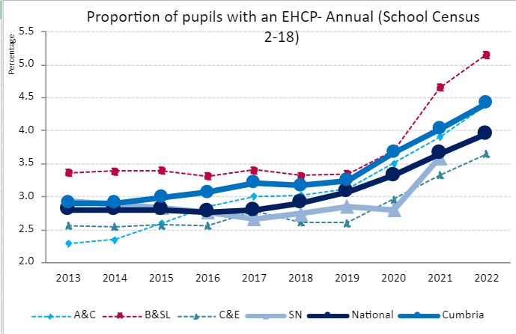
This is a national problem linked to the 2014 SEND reforms which introduced Education and Health Care plans without adjustments to the School High Needs block funding to keep pace with demand. It is based on a 10% annual increase in EHCPs in Mainstream Schools and a 5% increase in Maintained Special Schools.
Overall Cumberland’s EHCP rate mirrors the national profile and statical neighbours).
In terms of primary need:
- Autism Spectrum Disorder and Learning Disabilities are the leading primary need in Maintained Special Schools;
- Autistic Spectrum Disorder and Speech Language an Communication Needs are the leading primary needs in Mainstream schools (NB. SLCN is likely to increase as children in early years age phases during the COVID-lock downs pass through the education system)
Modelling conducted for Cumbria County Council by the consultancy firm Mastadon, shows that this is part of a longer-term trend that Cumberland will need to factor in as shows in the chart below.
Future SEND and EHCP Projections:
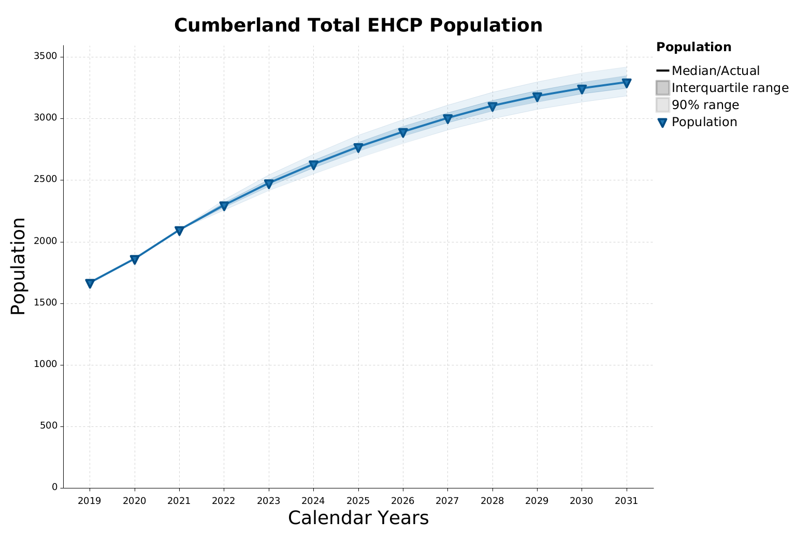
While EHCPs linked to complex physical disabilities is likely to continue to decline, due to improvements in medical interventions, the three main areas driving the increase are: Autism Spectrum Disorder (ASD), Speech, Language and Communication Needs (SLCN) and Social Emotional and Mental Health Difficulties (SEMD).
Mastadon notes that ‘demand for special school places in Cumberland and Westmorland is expected to be in the region of hundreds of places over capacity.’
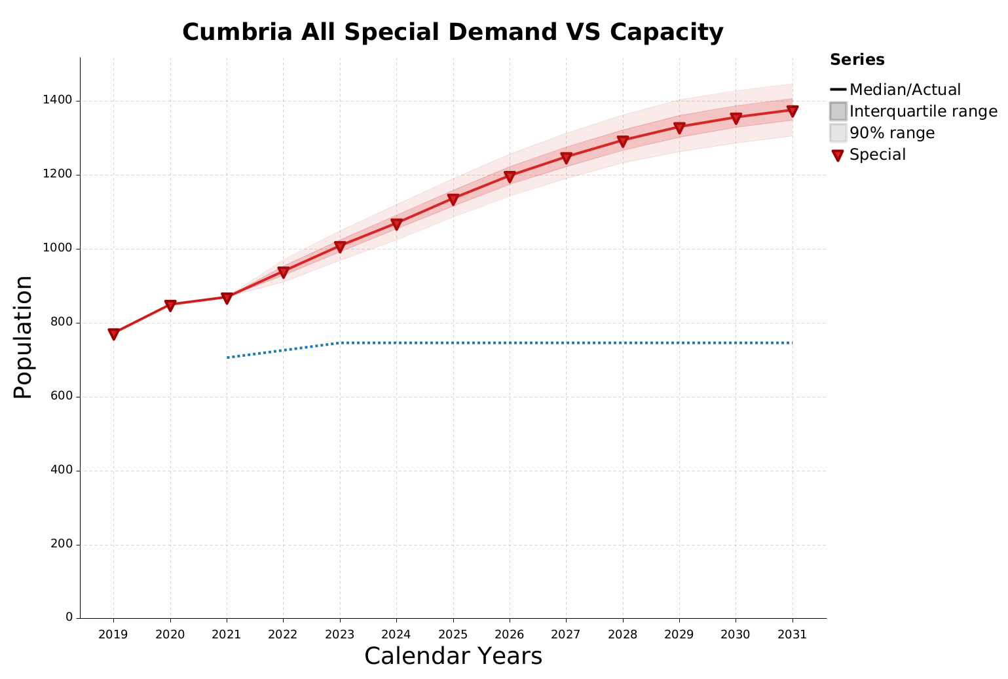
Mastadon’s conclusions are as follows:
- Evidence of a growing SEND population despite a falling overall school age population
- Cumbria’s SEND population set to increase by around 340 individuals between 2021 and 2022
- Population growth is set to become fairly stable, although the overall population size is will be driven by the recent population spike ageing through the SEND system
- Independent Special schools set to increase on average by 12 students a year for the next five years
- Availability of provision and biases in diagnosis likely drivers of differences between Cumberland and Westmorland SEND projections
- Demand for special school places in Cumbria is massively outstripping capacity, even with the recent increase
- Within one year demand for special school places in Cumberland and Westmorland is expected to be in the region of hundreds of places over capacity
- Many SEMH EHCPs are being diagnosed at Secondary phase, suggesting these SEND needs are not being captured early enough
- An indication of ‘repeated placement breakdown and/or insufficient diagnoses, as most movements to Independent Special Schools are from mainstream schools where either an EHCP is already provided or the movement is accompanied by a new EHCP.
- The estimated cost for all new, unplanned Independent Special School ECHPs between 2020 and 2021 was over £1.7m’ (in Cumbria)

What are the opportunities?
Cumberland Inclusion Strategy: The Cumberland Inclusion Strategy is currently in development and will be taken to Executive in September 2023.
The Inclusion Strategy sets out a vision underpinned by the following principles:
- Early Intervention and Prevention: to ensure that support is available and clear action is taken at the earliest indication of need.
- Mainstream Integration: the majority of children should be able to access the support they need in their local early years, primary or secondary school setting. All school leaders should place inclusion at the heart of their decision-making.
- Consistent support regardless of location: so that, no mater where they live, children, young people and their families can expect to access the support they need.
- Sufficient, accessible, high quality non-mainstream provision where it’s needed: to ensure that those with the most severe or complex needs can access the specialist settings and professional help they require within a reasonable distance of their home
- Participation: regular opportunities for children, young people, their families and practitioners to feedback on how the system is working, and where it could improve
The Inclusion Strategy will be delivered through 7 priorities reflect the various components that make up the SEND and school inclusion system. In setting out the priorities were a clear that by taking action on each of these components, we are improving the inclusion of the system as a whole.

Delivering Best Value (DBV): Cumberland and Westmorland and Furness Councils have each received £1m DfE DBV funding to establish a 2-year improvement programme to put in place measures to reduce cumulative pressures on the High Needs Block.
The programme which began at the beginning of the financial year consists of two workstreams.
Maintained School Inclusivity
- Aim: Increase numbers of children supported within a mainstream educational setting whose needs are met without an ECHP;
- Approach: Recruit team to provide targeted support within schools with low levels of inclusivity; introduce new dashboard to better target schools and identify children earlier; invest in an extensive staff and SENCO training programme to embed enhanced understanding of SEND, better early identification and support; earlier response to schools requiring capital investment to make changes to provide greater support to pupils at risk of otherwise going to special schools.
Service Utilisation
- Aim: Reduce late identification of need and reduce gaps in service.
- Approach: Service mapping, stronger referral and outcome monitoring.
The DBV programme is a workstream that is accountable to the wider SEND Partnership
Implementation of the SEND Improvement Programme and the local partnership.
Lag and Lead indicators
The following indicators provide an indicative outline of some of the potential indicators that could be broken down to inform individual staff behaviour and practice.
The following lag indicators link to the Challenge.
- Cost of High Needs Block
- Fixed term exclusions for SEND
- Appeals by parents challenging EHCP decisions
- Numbers of children attending Independent Special Schools due to maintained sector not meeting their needs
- Numbers of children placed out of county.
Outcomes | Lead Indicators
Maintained School Inclusivity | - Capital adaptations to settings to improve inclusivity  - Proportion Children supported and prevented from applying for an EHCP  - Children prevented from moving to a Maintained or an Independent Special School
Service Utilisation | - % parents satisfied with EHCP decision and support  - Early diagnosis of ASD and SEMH  - % of children in settings appropriate for their needs  - Parental satisfaction with Short Break offer.

Challenge 3: Home to School and SEND Transport Pressures
What is the problem?
One of the consequences of the increase in SEND and EHCPs is financial pressure on the Local Authority home to school transport provision. Nationally this is leading to the following trends:
- Increasing procurement of single person journeys;
- Increasing number of pupils in non-mainstream Alternative Provision, Special Schools, Pupil Referral Units and settings that are a greater distance from home, which require additional high-cost routes;
- An increase in parental choice driving higher numbers of EHCPs and increased expectation of door-to-door transport arrangements.
There are also supply factors that are driving up costs nationally:
- Tight local transport markets leading to high-cost contracts to attract local competition for routes and provision;
- The Impact of Public Service Vehicle Accessibility Regulations 2000 (PSVAR), which came into effect in 2020 and requires all vehicles with more than 22 seats to meet disability accessibility criteria. This has led to some suppliers having to purchase new fleet.
- The impact of inflation on transport costs throughout the supply chain.
In 2023-4 year the budget allocated is £5,155,000 for mainstream transport and £5,112,000 for SEND transport. However, there are significant pressures due to:
- James Rennie School in Carlisle and Mayfield School in Whitehaven opening new sites in Carlisle and Cockermouth;
- An approx. annual 9% increase in SEND pupils eligible for transport due to increasing parental and professional completion of Education and Healthcare Plans;
- High levels of single vehicle journeys, restricting transport available and increasing the costs charged to the Council for remaining vehicles.
- An increase in transport classed as ‘exceptional’ over the past two years from 96 in Cumbria to over 100 in Cumberland alone.
- The Spare Seats scheme, where parents can pay for any additional seats on a vehicle is set at £458.40 per annum, which is considerably lower than other local authorities and does not cover the costs.
For the child this means:
- Loss of opportunity to build independent travel into SEND pupils learning with knock on effects post-16 and in adulthood;
- Higher numbers of pupils travelling separately from their peers, especially in Mainstream education;
- Not benefitting from the flexibility of an Independent Travel Payment.

What is the evidence?
This is exacerbated by the following local factors:
- Average per pupil cost for SEND is £3,000 more than the average comparable councils (at over £9k per annum);
- Cumbria has much higher numbers of SEND related single person journeys (at £15,000 average per pupil per annum), (48% compared to 38% for statistical neighbours)
- An overreliance on private transport hire that is more expensive per mile than comparator Local Authorities (£7.50 compared to a range of £3.11-£6.10).
- A high-cost model relying on much higher levels of door-to-door transport than comparator authorities;
- Route-mapping software that does not allow for regular route reviews;
- A lack of functional integration between Children’s Services that oversees ECHPs and identification of transport need, and Transport and Procurement which oversee the commissioning and review of routes.
- A lack of investment in independent travel options and use of Independent Travel Payments as an alternative to procured transport.
- An historic reluctance to re-assess routes to school and rationalise the number of routes (and an historical increase as routes are added without reviewing older routes.
- The absence of a SEND Home to School Transport Policy that sets out the Council’s policy objectives and drives the function with a clear strategy for parental engagement.
- A procurement rather than Children’s Services led approach in which ECHP applications are automatically passporting ‘transport need’ without a check of independent travel alternatives and a virtual absence of Personal Travel Budgets (in comparison to Local Authorities that have used these to reduce costs).

What are the Opportunities?

Edge Public Solutions Review
In 2022 Cumbria County Council who commissioned Edge Public Solutions Limited to conduct an independent review. Their analysis looked at the Home to School Transport function, the Home to School Transport Market and other factors that influence provision. The report included detailed recommendations, that covered:
- Options to re-organise the Home to School Function on a shared Cumberland and Westmorland and Furness basis;
- Savings options that could potentially prevent escalating costs while reducing current expenditure by a minimum of 11% or £2.6m per annum (across Cumberland and Westmorland and Furness) over three years.

The report highlighted that a fundamental service transformation over the next 3 years could potentially deliver efficiency savings estimated to be at least £2.6m per annum across Cumberland and Westmorland and Furness, 11% of the current budget.
Other report findings:
- Route analysis indicated a potential to reduce routes by 12.5%
- A higher number of single person journeys than expected and a lack of resource to build continuous appraisal/re-appraisal of single journeys into the function
- Significant changes to the eligibility and application process to ensure travel need is adequately assessed as part of the Education and Health Care Plans
- Opportunities to reduce demand through independent travel trainers and introduction/expansion of Personal Travel Budgets to the same level as comparator Local Authorities
- Clearer school/partner and parental communications setting out eligibility, entitlements and expectations with focus on travel rather than transport.
The report recommended:
- The formation of a dedicated Integrated Travel Team (ITT) with direction from Children’s Services and support from Commissioning, Procurement and Contract Management.
- Investment in a more staff to reflect levels of investment in comparator authorities, including a Head of Service role.
- Creation of a Home to School Transport Board to oversee functional integration and service transformation and to create stronger co-ordination, leadership and accountability for savings delivery.
- Investment in new technological systems that can better interact with real-time data on routes and travel distances, as well as real time and more regular performance overviews by the team.
- Development of a clear corporate strategy and Home to School Transport policy that sets out the Council’s duties, plans and communication strategy with parents and carers.
The table below sets out the report’s estimation of savings from delivery of these recommendations.
Efficiency saving | Yr.1 | Yr.2 | Yr. 3 | Ongoing
Supply side
Re-procurement of supply contracts | £328,125 | £1,312,500 |  | £1,312,500
Route re-assessment | £184,000 | £740,000 |  | £740,000
Demand side
Reassess journeys under statutory threshold | £57,879 | £115,758 |  | £115,758
Travel training (50 children per annum) with 30k investment | £10,000 | £50,000 |  | £50,000
Personal Transport Budgets (50 children per annum) | £50,000 | £300,760 |  | £300,760
 | £620,005 | £2,353,260 | £2,626,137 | £2,626,137

Lag and Lead Indicators
The report and its recommendations provide an opportunity to develop lag and lead indicators that could be percolated to individual teams.
The following are potential lag indictors.
- Reduction in single person journeys
- Reduction in EHCPs that do not consider independent travel
- Reduction in routes
- Savings from reverse procurement (i.e., bidding down when letting a contract rather bidding up)
- Savings from the spare seats scheme being increased in line with the national average cost.
- Savings from packaging routes (so bidders have to combine routes that are highly competitive and routes with relative market failure)
Outcomes | Lead Indicators
Supply | - Increase in new suppliers offering competitive prices  - Increase in children using mainstream taxi services rather than procured solutions
Demand | - Families switching to Personal Travel Payments  - Children helped to travel independently  - Children who can travel safely to school within 3 miles of catchment school

Challenge 4: Levels of Educational Attainment
What is the challenge?
Overall Cumberland as a place has lower average attainment outcomes for Early Years (Good Level of Development at end of Reception year), at Key Stage 1 and Key Stage 2 (transition to secondary school) and at Key Stage 4 (GCSE).
Schools in Cumberland are 80-90% rated good or outstanding by Ofsted, which points to wider contextual factors driving the attainment challenge, rather than what is happening within the school. Reversing these trends would require a long-term public health approach to addressing the contextual root causes that feed into eventual inequalities in attainment.
Before considering attainment it is important to note:
- The distinction between progress and attainment. Attainment is the outcome and progress measures relative improvement – if attainment describes the problem, progress describes the improvement journey. Progress 8 is the main measure to track whether a school is supporting progress across the curriculum and is a priority in Ofsted inspections.
- Average attainment scores mask significant variability from school to school even in the same catchment area.
- Local Authorities have little direct influence over progress and attainment, but a large influence on the wider conditions that support learning – through Public Health, neighbourhood and community services, Children’s Social Care, as well as specialist education related services including the Learning Improvement Team, Specialist Advisory Teachers, Children Missing Education, Elective Home Learning, Family Learning, Free School Meal Provision and Free School Uniform Grants.
- The Council also has a significant strategic role in working in partnership with School Leaders, including Cumbria Association of Secondary Heads, Primary Heads Association and other leaders of education and skills provision, including leading the Early Years Strategic Partnership group which addresses key priorities for multi-agency partners on a 3 yearly cycle.

The overall headlines for average attainment are:
- Carlisle’s overall average attainment rates at all age phases lag both the national average and the attainment levels in Allerdale and Copeland;
- Cumberland faces particular challenges for disadvantaged children transitioning from early years to primary school – this applies to Carlisle, Allerdale and Copeland;
- Primary to secondary transition average attainment has fallen below the national average in 2022, following pre-pandemic trend of being higher than national average
- GCSEs continue to be below national average, reflecting a longer-term trend in Cumberland.

Key factors behind this include:
- The impact of lost learning during COVID-19 is likely to have impacted early years and primary education more than secondary education; i.e., children currently being assessed for Good Level of Development would have been 2-3 years old during the lock-downs; KS 1 and 2 pupils would have been 6-7 years old; GCSE pupils would have been 13-14 years old and completed more education and child development prior to 2020.
- COVID may also have played into an increase in Cumberland’s rate of unauthorised absence from school and children being Electively Home Educated (500).
- Primary Schools and Early Years settings are reporting increased levels of challenges with parenting, including a rise in children who are not toilet trained by age 4, and poverty related issues (which links to the Early Help and family support challenges which are feeding into recent increases in statutory intervention);
- Schools increasingly responding to safeguarding and Early Help support issues (including increasing children missing, exploitation and emotional health and wellbeing challenges in Secondary schools) with an inconsistent Early Help offer at a school to school level;
- Increased pressures on school budgets over the past 10-12 years and increased pressures due to the growth of the High Needs block along with too many schools with inadequate investment in capital and infrastructure. This results in pupils being ‘offloaded’ where vulnerable children end up in special schools or become elective home educated;
- The local authority having a limited influence on Academy Trusts who employ in-house school improvement teams, so that there is less robust external challenge than when local authority learning improvement teams work with Head Teachers from Locally Maintained Schools (this is exacerbated in Carlisle where there are more secondary Multi-Academy Trusts with primary feeder schools accessing in-house MAT School Improvement Services).
- The link between aspiration, entry level employment and attainment: in Carlisle there are a large number of GCSE Grade 4 jobs which incentivises young people to aim for Grade 4 rather than higher; in West Cumbria the opposite happens with entry jobs in Sellafield being too high for many pupils who do not have the same range of employment opportunities as in Carlisle.

For the child this means:
- Too many children are starting life without the cognitive, physical and emotional level of development they will need to succeed at school;
- Too many children at risk of lifetime disadvantage because they have not acquired a basic standard of reading, writing and numeracy skills by the time they reach secondary school, and by the time they complete their GCSEs;
- Too many young people prevented from pursuing the post-16 and post-18 education, employment, and training pathways they might otherwise have chosen.
What is the evidence?
Overall attainment
Levels of attainment is lower than the national average for Academic Year 2022. While this may be impacted by COVID-19 absences, which were higher in Cumberland than nationally, it is based on structural population attainment challenges, especially inter-generational poverty.
There are disparities within Cumberland with Carlisle’s average attainment being consistently lower across all age phases. Overall:
- Cumberland lags the national average for priority areas of Attainment 8 (which measures progress) and Grade 9-4 in English and Maths (which measures attainment) with Carlisle lagging furthest in both sets of scores;
- Copeland scores above national average for all KS 1 scores;
- Carlisle: lags the both the national and the attainment levels at Copeland and Allerdale for all most all stages.

Table: Key Educational Attainment metrics by District (AY 22)
 | National  (AY 22) | Copeland | Allerdale | Carlisle
Attainment 8 | 48.9 | 47.1 | 47.4 | 44.4
Pupils achieving E-Bacc Grade 4+ | 26.9 | 20 | 28.9 | 20.5
Grade 9-4 in English and Maths | 69 | 66.2 | 67.4 | 61.5
KS2 pupils achieving the expected level in all subjects (RWM) | 58.9 | 57 | 52.4 | 53.6
KS1 pupils achieving expected standard in Reading | 66.9 | 66.4 | 63.7 | 60.1
KS1 pupils achieving expected standard in Writing | 57.6 | 60.1 | 54.9 | 49.6
KS1 pupils achieving expected standard in Maths | 67.6 | 70.4 | 66.5 | 61.7
Reception pupils achieving a Good Level of Development | 65.2 | 61.1 | 62.1 | 57.3

Disadvantage attainment
All pupils who qualify for pupil premium (including Children in receipt of a Free School Meal) are classified as disadvantaged.

The disadvantage attainment level is a significant indicator for the impact of child poverty on a person’s long-term life chances in the economy.

Nationally there is an average attainment gap of 27% at Maths and English GCSE, which is reflected at all stages with reception pupils experiencing an average 19% attainment gap.

In Cumberland overall the average disadvantaged gaps are wider than nationally especially in Carlisle, though notably in Copeland where there is the highest for GCSE average attainment in Maths and English.

The biggest average gap overall is in Early Years Good Level of Development where all three areas of Cumberland where the average attainment gap between disadvantage lags both national overall GLD (-29%) but also national disadvantage GLD (-13%).

Table: Key Educational Attainment metrics for disadvantaged pupils (AY 22)
 | Non-Disadvantaged (%) | Disadvantaged/ FSM %
 | National  (AY 22) | National | Copeland | Allerdale | Carlisle
Attainment 8 | 53 | 38 | 34 | 35 | 34
Grade 9-4 in English and Maths | 76 | 49 | 34 | 43 | 41
KS2 pupils achieving expected standard in Reading | 80 | 62 | 63 | 64 | 57
KS2 pupils achieving expected standard in Writing | 76 | 55 | 55 | 48 | 44
KS2 pupils achieving expected standard in Maths | 78 | 56 | 53 | 47 | 47
KS1 pupils achieving expected standard in Reading | 72 | 51 | 46 | 43 | 46
KS1 pupils achieving expected standard in Writing | 63 | 41 | 33 | 37 | 37
KS1 pupils achieving expected standard in Maths | 73 | 52 | 50 | 53 | 47
Reception pupils achieving a Good Level of Development | 68 | 49 | 36 | 39 | 35

What are the Opportunities
Given that schools are directly responsible for delivery of the curriculum, the main focus of the Local Authority is on the wider context that supports what happens within the school. Based on the examples below, a second phase of work would be required to map the supporting services and interventions the Council (and partners) lead on, and to develop these into a strategy and lead indicators to support all age/phase education settings.
Early Years: The Early Years outcomes are fragmented between health and educational/child development outcomes that would benefit from greater strategic oversight. Cumberland also has a mixed-economy in relation to Early Years provision with PVIs, school nurseries and child minders.
There is an opportunity to utilise the review of the Healthy Child Programme service and the 0 – 19 Child and Family Support Service to develop a more coherent package of support that brings health and educational outcomes more closely together.
It would also provide an opportunity to address the gap in specialist services for children in the early years who are experiencing attachment and social and emotional issues (currently CAMHS and My Time start at age 5).
Through the Family Hub and the review of the 0-19 services ahead of 2024, there is an opportunity to develop more integrated and consistent service offer that can develop a plan for all children from the first 1001 days from conception to Good Level of Development. This could include:
- A consistent approach to speech and language development, physical activity and access to nutritious food;
- Support for nurturing parenting and healthy attachment within a model of interdependence and community support;
- Opportunities for parents/carers to take part in the running of services with volunteering and employment opportunities;
- Welfare support for families including: right to food, access to sustainable nappies, access to sterilisation and hygiene products;
- An integrated service that can provide support to families on the wider determinants of health (i.e., money advice, benefit checks, healthy start vouchers, free nappies and sterilising products, support around cost of living and access to the Household Support Fund etc.) and helps to meet emotional health needs of children and their families
.
Early Help in Schools: The pilot Social Worker in Schools and Reflective Supervision in Schools programmes have begun to demonstrate the impact of co-location of professional support within the school.
This model could include strengthening the in-house school nursing offer, and potentially linking into the No Wrong Door model (if adopted) in secondary schools where there are children at risk of NEET.
Western Excellence in Learning and Leadership (WELL): In Allerdale and Copeland districts, the WELL project is a partnership project between the County Council, Sellafield and the NDA to focus on a range of education-related issues in the area through collaboration and partnership. Significant funding is in place to support the project which offers a model of using anchor institutions to support the school system.

Lag and Lead Indicators
The following are potential lag indicators linked to educational phases:
- GLD attainment gaps overall, in each district and disadvantage (annual)
- KS 1 and KS 2 attainment gaps
- GCSE Grade 9-5 (identifying Grade 5 as the most crucial cut off point)
Outcomes | Lead Indicators
Early Years | - Increased average vocabulary of child ages 2  - Increased GLD in LSOAs in the highest decile of deprivation nationally  - Increased GLD in targeted communities and primary school catchments where there is the highest gaps
Primary | - Increased KS1 and KS 2 outcomes overall  - Increased KS 1 and KS 2 outcomes in schools whose catchments include LSOAs in the highest decile of deprivation nationally compared to Cumberland average  - Increased KS 1 and KS 2 outcomes in Locally Maintained Schools with access to Cumberland Council’s School Improvement Team
Secondary | - Increased Progress 8 measures overall  - Increased Progress 8 in schools whose catchments include LSOAs in the highest decile of deprivation nationally compared to Cumberland average  - Increased Progress 8 in Locally Maintained Schools with access to Cumberland Council’s School Improvement Team
Post-16 | - Increase in overall Higher Education access  - Increase in disadvantaged pupils progressing to A-Levels and degrees  - Increase in apprenticeships leading to career paths in anchor institutions  - Increase in Care Experience EET, A-levels and University access  - All anchor institutions to treat Care Experience as a protected characteristic in recruitment policies.

N.B. School progress and attainment data are collected annually, so these headline indicators would need to be broken into smaller steps to measure performance that will drive improvement at the headline level.

Challenge 4: Health Inequalities
What is the challenge?
Work on planning the Family Hubs has identified 4 key health related challenges for children in Cumberland:
- Early Years health checks
- Maternity support
- Obesity
- Mental Health
In each of these areas Cumberland is a) in the bottom quartile nationally b) has seen things get worse over the past few years.
The recent SEND Inspection (December 2022) highlighted access to CAHMS as a particular challenge and more progress required overall and highlighted deficits in support for those with autism.
For children this means:
- Children not having the best start in life;
- Health checks at 14 days/6 months/1 year and 2 years not happening enough
- Too many children obese at reception, despite recent improvements.
- Too many children aged 10-15 years old requiring mental health support and not enough boys seeking support
- Children waiting too long to receive mental health support;
- Long term damage to physical and psychological health.
The recently commissioned Children’s Emotional Health and Well-Being Joint Strategic Needs Assessment (JSNA) identified opportunities for improved evidence-gathering in order to develop effective strategies to meet this need.
What is the evidence?
Early Years
Cumberland lies in the bottom quartile for numerous indicators at all stages of the Early Years services (from neonatal reviews to hospital admissions at age 4). This will be the top priority for the Family Hubs in phase 1 and 2.
Data from OHID (Office for Health Inequalities and Determinants) shows that:
- Children at reception, they are placed in the bottom quartile for: obesity, school readiness with regards to personal, social, emotional, and physical development, and literacy skills.
- Neonatally, Cumbria lies in the bottom quartile again for New Birth Visits within 14 days, and in receiving regular reviews for the first 2 years of life at every stage: 6-8 weeks, 12 months, and 2 years.
- Children under the age of 4 are also more than 3 times more likely to be admitted to hospital due to an unintentional or deliberate injury.

Looking closer at pregnancy indicators at a district wide level, we can see that the Cumberland population is at risk for numerous risk factors during pregnancy:
- mothers are 2.6% more likely to be obese during their pregnancy, 1.5% more likely to smoke and babies are 12.2% less likely to be initially breastfed.
However, we can see that Cumbrian healthcare services are exceptional at providing early access to maternity care, placing 1st in the Northwest of England and 8th in the whole of England
Mental Health
There has been a significant increase in the number of referrals for children and young people's mental health services. From 2019 to 2022, there was an almost 100% increase in referrals to Cumbria, Northumberland, Tyne, and Wear NHS Foundation Trust (CNTW).
A report by Young Minds (2021) found that children and young people in Cumberland face long waiting times, limited choice of services, and difficulty accessing specialist support.
Further data shows:
- Children and young people experience more than an 18 week wait for treatment in 56% and 42% of cases respectively;
- 683 referrals a month in North Cumbria to NHS mental health services;
- 255 days waiting time to access Barnardo’s ‘My Time’ service.
- Similar average waiting times for Barnardo’s “My Time” service: 255 days.
- 68% of all NHS specialist treatment referrals are aged 11-15;
- For Kooth, MHST and My Time girls make up over 60% of referrals and boys under 40% with reporting 8% whose gender is non-binary.
The 2022 SRQ Report identifies family concerns which highlights:
- Highest level of concern being a family member becoming ill;
- Significant levels of children showing anxiety or other worrying behaviours
- Particular concerns in Allerdale and Copeland compared to Carlisle (and out of proportion to the underlying % of children in Allerdale compared to Carlisle);

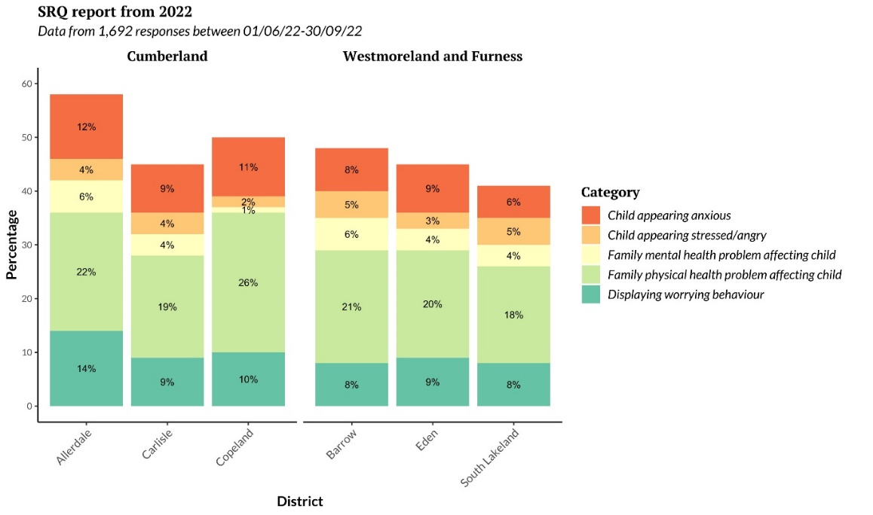

It is important to note that these increases relate to school age children, and that many of the specialist psychological and therapeutic services are not available for children aged under 4 years old.
Childhood Obesity
Childhood obesity is a longer-term issue for Cumbria. The Quarter 3 Corporate Performance Report (Cumbria County Council) shows a reduction in levels of obesity the last quarter across the Cumbria footprint, with 26% of children in reception overweight or obese compared to 23.0% nationally (19/20). This figure increases to 37% in Year 6 compared to 35% nationally (19/20).

Table: % of children who are overweight by Unitary Authority
 | National | Cumberland | Westmorland & Furness
% reception pupils who are overweight (including obesity) | 23% | 27% | 31%
% Year 6 pupils who are overweight (including obesity) | 35% | 34% | 37%

Issues are often complex and there is often a correlation with Early Help and Special Educational Needs & Disabilities; this is then often linked to other services to support the family on wider issues.
A whole system approach was adopted by Cumbria County Council, maintaining and developing Cumbria’s universal proportionate pathway for children, young people and their families which includes prevention and early intervention. The Healthy Habits for Life programme is in place with longer-term funding and now targeted at primary schools. Further resources and pathways for schools include the E-school nurse promotion, so when there is a specific issue, there is a package of support to address Healthy Weight as part of a whole school approach. The Early Years Healthy Families Pledge (Cumbria) has been a key programme and could be refreshed and taken forward within Cumberland

What are the opportunities?
Lag and Lead Indicators?
- Healthchecks up to age 2
- Obesity at reception
- Demand for Mental Health Services (especially for children aged 10-16)
- Safeguarding referrals for Domestic abuse and Neglect
Outcomes | Lead Indicators
Maternity and Early Years | - Increased access to physical activity and nutritious food for parents, babies and pre-school  - Health visits in highest national quartile
Mental health | - Improvements in children self-reporting better mental health

Appendix 1: National and Government Policy for Children and Families
This appendix provides a summary from the following key pieces of national policy:
- DfE SEND Action Plan (2023)
- Josh McAlister Independent Review into Children’s Social Care (2022)
- DfE response to McAlister Review: Stable Homes Built on Love (2023)
DfE SEND Action Plan (2023)
The Plan is a policy paper setting out the Government’s response to the outcome of consultation on the SEND and Alternative Green Paper published 29.3.2022.

The Green Paper identified three key challenges:
- Challenge 1: Outcomes for children and young people with SEND or in AP are consistently worse than their peers across every measure
- Challenge 2: Navigating the SEND system and AP is not a positive experience for children, young people and their families
- Challenge 3: Despite unprecedented investment, the system is not delivering value for money for children, young people and their families.

In response, the Plan has identified several areas of focus with milestones for delivery between 2023 and 2025.
- National system underpinned National Standards
- Successful transitions and preparation for adulthood
- Skilled workforce and excellent leadership
- Strengthened accountabilities and clearer routes of redress
- Financially sustainable system.

Overall, the Plan seeks to introduce a SEND and AP system with national standards and regulation, backed up by local partnerships and improvement plans and a more uniform digitally based applications process for Education and Healthcare Plans.

The reforms will take at least two years and even though many of the partnerships and local planning elements will be in place during 2023-24, any new statutory duties are unlikely to be in place until 2025-26 (or later).

Milestones for delivery of key elements of the Plan

Theme | 2023 | 2024 | 2025
National Standards | Spring: begin developing content |  | Publish significant portion of NS
National Standards | Winter: elements of NS ready for testing |  | Put NS on statutory footing with Legislation
Local Area Partnerships and Local Improvement Plans | Spring: Regional Expert Partners will begin testing with local areas | Regional Taskforce Teams target support for areas with most need | Primary legislation to put Partnerships on a statutory footing and mandate collaborative working
Local Area Partnerships and Local Improvement Plans | Autumn: Non-statutory guidance issued
Digitise EHCPs | Test digital solutions | Design drafts and test | Begin rollout
Inclusion Dashboard | April – Develop and test prototype
 | Autumn – Publish Dashboard
Mediation | Autumn - Review mediation for SEND | Autumn – Set out new mediation process

Independent Review into Children’s Social Care (2022)
The Independent Review into Children’s Social Care was commissioned by the Government and published on 23 May 2022, and sets out a reform programme ‘Relationships Protect’ based on the centrality of family-based support and an outcomes-based approach. Key areas of focused include:

Family Help – The report sets out a clear definition of Family Help based on a model of early community based and multi-disciplinary support in local areas to be supported by:
- clear national guidance on Family Help, including criteria and best practice models with flexibility for local areas to innovate their own models;
- multi-agency Family Help teams similar to that developed by Youth Offending Teams, but operating in universal community settings – i.e. Family Hubs, schools, community centres and youth clubs.
- multi-agency Family Help teams to be supervised by an expert child protection practitioner (qualified social worker), with further delegated powers to Directors of Children’s Services to co-ordinate multi-agency activity;
- Family help reforms to be considered alongside actions and changes that will flow from the SEND Green Paper, especially those relating to local planning for SEND and Alternative Provision.

Multi-Agency working – to support the focus on Multi-Agency working, the Report advocates:
- adding education/schools to the Local Authority, Police and Health as a fourth statutory Multi-Agency Safeguarding partner;
- promotion of pooled budgets to facilitate closer integration between health and social care under the co-ordination of the DCS;
- information sharing to be prioritised, with a clear plan for reform to be enacted by 2025.

Social Care – the report sets out five missions for the social care system:
- to build relationships and increasing life expectancy.
- to establish up to 20 new Regional Care Cooperatives to replace the existing mixed economy of local authority and private fostering care, and to oversee commissioning of residential homes;
- to run a national campaign to recruit 9000 foster carers;
- to introduce new universal standards for care;
- to invest in support for foster carers (package of £82m) and to expand the Staying Put and Staying Close programmes.

The Report makes a total of 9 recommendations.
R1. A new umbrella of “Family Help” should combine work currently done at targeted early help, ending handovers and bringing the flexible, non-stigmatising approach at early help to a wider group of families.
R2. Eligibility for Family Help should be set out in a sufficient level of detail nationally to give a more consistent understanding of who should receive Family Help, whilst giving enough flexibility to enable professional judgement and empower local Family Help Teams to respond to families’ needs.
R3. Local Family Help services should be designed in a way that enables families and practitioners to have a conversation about their concerns rather than relying on mechanical referrals. If families are not eligible for Family Help, support should be available in universal and community services and the front door to Family Help should be equipped to link families to this support.
R4. Family Help should be delivered by multidisciplinary teams, embedded in neighbourhoods, harnessing the power of community assets and tailored to local needs.
R5. Government should make an upfront investment of £2 billion in supporting local authorities and their partners to implement the proposed transformation in Family Help. National government pots of funding should be mainstreamed into this funding stream and partners should be incentivised to contribute. Once transformation is complete, the government should ring-fence funding for Family Help to ensure rebalanced investment is sustained.
R6. As part of the National Children’s Social Care Framework, the government should define outcomes, objectives, indicators of success and the most effective models for delivering help. Funding should be conditional on meeting the goals of the Framework.
R7. Alongside recommendations to strengthen multi-agency partnerships and the role of the Director of Children’s Services, the government should consider legislation to put the existence of multidisciplinary Family Help Teams on a statutory footing.
R8. Ofsted inspections should reinforce a focus on families receiving high quality, evidence-based help that enables children to thrive and stay safely at home.
R9. Government should ensure alignment in how the proposals in the SEND and Alternative Provision Green Paper and this review are implemented. Government should ask the Law Commission to review the current patchwork of legislation that exists to support disabled children and their families.

Stable Homes Built on Love (2023) Green Paper
In February the DfE published the following Green papers:
- Children’s Social Care Strategy: Stable Homes, Built on Love;
- Child and Family Social Worker Workforce plan;
- Children’s Social Care National Framework and Dashboard.

Collectively these consultations form the Government’s response to recent independent reviews including:
- The Independent Review of Children’s Social Care, conducted by Josh McAllister;
- The national Child Death Panel’s report into the deaths of Arthur Labinjo-Hughes and Star Hobson;
- The Competition and Markets Authority report on the care home market.

Following the consultations it is expected that the Government will publish its strategy and frameworks in September 2023.

Stable Homes, Built on Love sets out 6 pillars of delivery against a set of Government actions which are summarised in the table below.

Pillar | Government action
1: Family Help provides the right support at the right time so that children thrive within their families | - Family Help Pathfinders.  - Support the Family Help workforce including support to build their knowledge and skills.  - Joined up funding and strategy to ensure local areas are funded and supported to deliver effective services.
2: A decisive multi-agency child protection system | - Integrated and expert child protection response Pathfinders.  - Consult on new National Multi-Agency Child Protection Standards.  - Strengthen multi-agency leadership by amending guidance to Local Authorities, Police and Health, to be clearer on roles and responsibilities.
3: Unlocking the potential of family networks | - Test how to implement reforms to family group decision-making and Family Network Support Packages.  - Provide a training and support offer for all kinship carers in this Spending Review Period.  - Publish a national Kinship Care Strategy by the end of 2023.
4: Putting love, relationships and a stable home at the heart of being a child in care | - Deliver a fostering recruitment and retention programme.  - Regional Care Cooperatives Pathfinders to plan, commission and deliver care places.  - Programme to support improvements in the quality of leadership and management in the children’s homes sector.  - Introduce a financial oversight regime that will cover the largest providers of children’s homes and fostering agencies.  - Increase the leaving care allowance and the apprenticeships care leavers’ bursary.
5: A valued, supported and highly skilled social worker for every child who needs one | - Prioritise a career development for social workers by delivering an Early Career Framework. Social Work England will also quality assure all initial education routes for social workers.  - Support social worker recruitment and explore ways to support the recruitment of up to an additional 500 child and family social worker apprentices nationally.  - Improve social worker retention.
6: A system that continuously learns and improves, and makes better use of evidence and data | - Introduce a Children’s Social Care National Framework setting out children’s outcomes, a data Dashboard and Practice Guides.  - Publish a data strategy by the end of 2023.  - Align inspection to the Children’s Social Care National Framework.

In the table below, the Milestones for Phase 1 are detailed by each of the main sub-themes.

Laying Foundations
Activities | 2023 | 2024
Families First Children’s Pathfinders | Wave 1 September) | Wave 2
Regional Care Cooperatives | Wave 1 (Summer) | Wave 2
Early Career Framework | Early adopters (Spring)

Addressing Urgent Issues
Activities | 2023 | 2024
Foster Carer Recruitment and Retention | NE hub (Summer)  Regions for wider roll out selected (Autumn) | Support hub marketing launch in new areas
Training and support to kindship carers | Delivery partner contract award (Autumn) | Delivery commences (Spring)
Access to Family Finding | Bidding round for funding (Spring)
Uplift leaving care allowance | Increase allowance to £3000 (April)
Agency social workers | Publish national rules for agency use (September) | New rules in place (Spring)

Setting National Direction
Activities | 2023 | 2024
Implementation Strategy | Issue consultation (February  Consultation close (May)  Government response (September)
Children’s Social Care National Framework and Dashboard
Children’s Social Care National Framework and Dashboard | Issue national Guidance (Autumn)
Social Worker and Workforce: proposed reforms to agency market | Issue consultation (February)  Consultation Close (May)  Government response (September)
Working Together to Safeguard Children Statutory Guidance | Consultation (Spring)  Issue updated Guidance end 2023 | Annual updates of Working Together Guidance.
Information Sharing between Safeguarding Partners | Consultation (Spring)  Issue updated Guidance (Winter)
Social worker workforce Early Career Framework | Consultation as necessary (from Autumn 2023)
Key publications | Report to Parliament on Information Sharing and Consistent Child Identifier (summer)  Data Strategy (Winter)  National Kinship Care Strategy (Winter) | Knowledge and Skills Statement for Family Help Workers (summer.

Appendix 2: Feedback from Regulators
S 2.1 Ofsted Inspection of Local Authority Children’s Services (ILACS) Report September 2022
Overall Inspection Outcome: Requires Improvement to be Good
- Help and protection: RI
- Experience and progress of children who need help and protection: RI
- Experience and progress of children in care and care leavers: Good
- Impact of leaders on social work practice with children and families: RI
Strengths Help and Protection
- Strong front door – appropriate application of thresholds
- Children benefit from wide range of Early Help support
- Timely strategies and thorough investigations
- Children who have gone missing are visited regularly and their views are understood
- Disabled children are receiving more effective support
- Effective Edge of Care services are a strength
- Public Law Outline (PLO) is reducing level of drift

Strengths Children in Care
- The Children in Care are those who need to be in care and permanence decisions made promptly.
- Children in Care are living in stable homes, feel safe and make good progress
- Care plans consider children’s wishes and feelings
- Children in Care Councils are a strength
- Foster carers are positive about the local authority’s support
- Care leavers well supported
- There is commitment and investment in improving the child’s choice of home.

Areas to Improve
- Response to children who go missing or at risk of exploitation
- Response to children suffering long term neglect – especially in terms of parental support and child poverty
- Consistency of quality of assessments and plans
- Impact of oversight and challenge from leaders, managers and Independent Reviewing Officers
- 16/17 homeless – rights and options

Independent Reviewing Officer Annual Report for Cumbria April 2022
- 15.9% increase in children on a Child Protection Plan creating increased Social Worker Case loads – this reverses a declining trend from 2018-2021.
- Annual numbers of children in care remaining static.
- Children living out of the area up by 6 (making up 28.7% of children in care).
- Overall performance is strong with 94% of children in care reviews on time.
- A key challenge is business continuity in partner organisations, especially the NHS in providing timely support.

Key plans
- CYP Post-Inspection Improvement Plan (2023)
- SEND Continuous Improvement Plan (2023)

These figures are based on an assessment of returns on investment of adopting No Wrong Door.
https://bettercarenetwork.org/library/principles-of-good-care-practices/leaving-alternative-care-and-reintegration/interdependence-careleavers-views-bright-spots-programme-findings
https://www.gov.uk/government/publications/send-and-alternative-provision-improvement-plan
https://www.gov.uk/government/consultations/send-review-right-support-right-place-right-time

