24 March 2025

Dear Recipient

STATUTORY CONSULTATION: PROPOSED RAISED SPEED TABLE – SCALEGILL ROAD, MOOR ROW

I am writing to you as part of a statutory consultation to inform you that RG Parkings/Thomas Armstrongs propose to install a new raised speed table as shown on the plan overleaf.

RG Parkins are proposing to install a new raised speed table as part of the new development which is to be built on Scalegill Road, Moor Row. This will replace the existing speed hump in an attempt to incorporate the new junction.

Full details of the proposed change, together with plans showing the road concerned, may be viewed on the Council’s website. - https://www.cumberland.gov.uk/parking-roads-and-transport/streets-roads-and-pavements/road-maintenance-closures-and-improvements/proposed-traffic-regulation-orders-tros

Cumberland Council invites you to comment on the proposed scheme. Please ensure that your feedback, whether in favour of or against the change, is received in writing to the above address or email to TROresponses@cumberland.gov.uk quoting the reference “Scalegill Road” by the 16th April 2025.

Yours faithfully
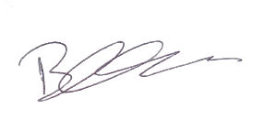
Ben Carter
Traffic Management Team Leader

