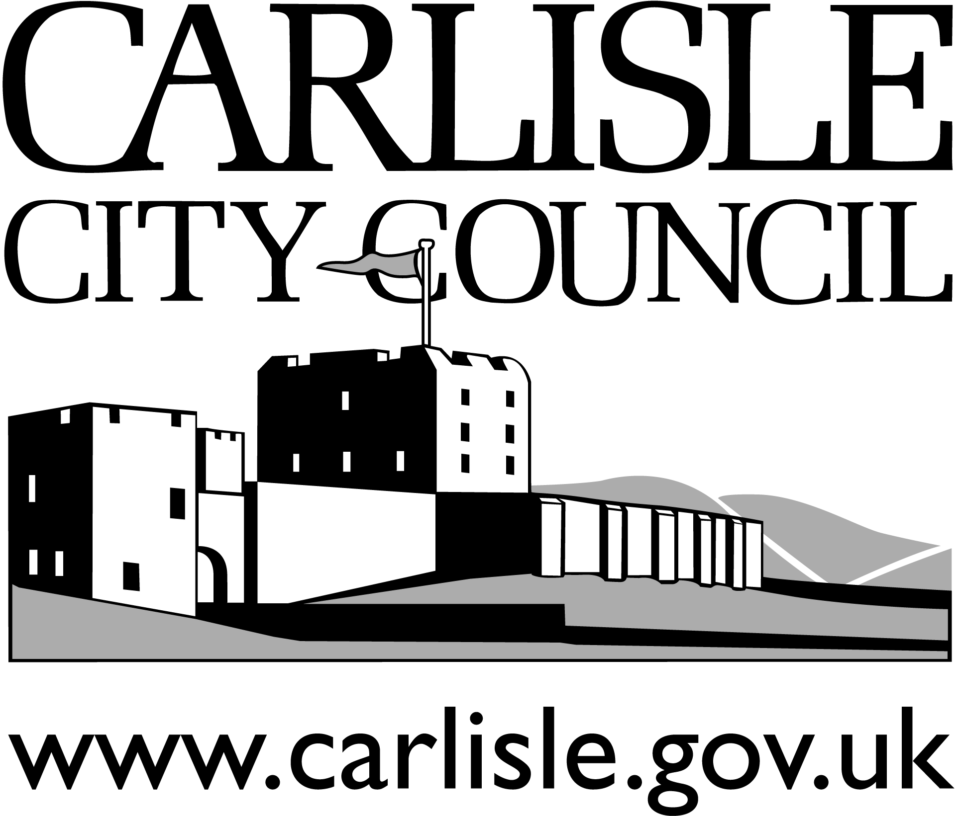

Bylaws relating to: Electrolysis

Guidance for Electrolysis.

Under the Local Government (Miscellaneous Provisions) Act 1982 any person wishing to carry on the business of Tattooing, Ear Piercing, Electrolysis or the practice of Acupuncture needs to be registered with the Local Authority.

Under the above Act the premises, where the business is to be carried out must also be registered. This registration will remain in force on the premises providing there is no transfer of ownership of the business.

This guidance note aims to provide information on best practice standards of hygiene and provide information on the facilities required in Ear Piercing establishments in compliance with the councils Bye laws made under the above Act to secure cleanliness of the registered premises and fittings and persons responsible for sterilisation and cleanliness.

Premises
The premises must be clean and capable of being kept clean. All internal parts of the structure of the premises should be maintained, kept clean and in good repair. All electrical equipment shall be visually inspected and electrically tested in accordance with the Electricity at Work Regulations 1989.

An accessible wash hand basin with a hot and cold water supply connected into an operational drainage system is required together with soap (bactericidal) and an hygienic means of drying hands (disposable and machine auto rolled towels).

Table tops and other working surfaces should have a smooth impervious surface and be capable of being cleaned and disinfected. Chairs, seat and couches should be capable of being regularly washed with hot water and disinfectant, fabric chairs should not be used.

In addition adequate ventilation and artificial lighting should be provided and maintained.

First Aid
A first aid kit, compliant with the Health and Safety (First Aid Regulations) 1981 should be available. A qualified basic first aider must be available on site.

Health and Safety At Work
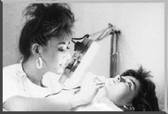
Under the Health and Safety at Work etc Act 1974, ear piercers have a duty to conduct their undertaking in a way so as to ensure, so far as is reasonably practicable that persons are not exposed to risk to their health and safety. An assessment of the facilities, their cleanliness and adoption of safe procedure for electrolysis should be adopted and implemented in fulfilment of this obligation together with procedures for accident reporting in accordance with the Reporting Of Injuries, Diseases and Dangerous Occurrences Regulations 1995.

Personal Hygiene
The beautician must ensure that his/her own health does not endanger in any way the health of the client’s and must maintain high standards of personal hygiene at all times.

- Hands should be frequently washed
- Cuts and wounds must be washed and dressed.
- Wear clean washable or disposable clothing.
- Refrain from eating, drinking and smoking whilst carrying out treatment.
- Must consult a general practitioner about any illness that may be of an infectious nature.
- The beautician shall not be under the influence of drugs, alcohol or other substances.

Disinfectants and Sterilisation
Adequate sterilisation and disinfecting of equipment should be maintained at all times. Consideration should be given to the sterilisation and disinfectant methods applied.
Disinfectants do not sterilise, but when used at the correct dilution factors disinfectants can reduce the number of germs present reducing the risk of patient infection. When selecting a disinfecting method or sterilisation technique an assessment needs to be made of the suitability of the method. Consideration should be given to the practicability of the chosen method, the product properties, storage requirements and ability to destroy various germs, etc must be considered.

Manufacturers and suppliers data sheets and pharmacist advice should be obtained when determining the right product for the task. This information will also be useful when carrying of a COSHH assessment.

Contra-Indications and Patient Care
All beauticians should have knowledge of the contra indications and should discuss with the clients their general health.
Discussion should include:

- The health of the client:
- History of hepatitis has the patient got ineffective hepatitis and is not currently suffering from it?
- Visual examination of treatment area,- it is free from cuts, any scaring or cellulitis
- Any allergic responses (product ingredients, essential oils, teat tree etc.
- Impetigo
- Genital warts
- Diabetes
- Varicose veins
- HIV infection
- Assessment of clients fitness for treatment i.e not under the influence of drugs, alcohol or other substances.
- Any medication.

Names and addresses of all clients and their General Practitioners (GP) details should be obtained together with a record of the dates of treatment.
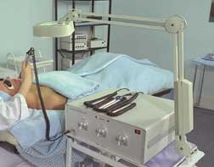
Where a condition exists or has occurred, written authorisation from the clients GP should be obtained prior to treatment.

After Care
After care advice information must be provided verbally.

Advice should contain the following information:

- Not to shower after treatment or apply deodorant, perfumes of body lotions.
- Redding should subside after 24 hours.
- Swimming, saunas and sun beds should be avoided for 24 hours.
- Treated area should be kept clean and dry.
- Advice on when to seek medical attention.
- The salon contact details.

Recommended Methods
The council has approved the following methods of electrolysis.

- Short Wave Diathermy (or Radio Frequency)
2. Galvanism
3. Blend (a combination of Short Wave Diathermy and Galvanism)
(For more information on the above methods please contact the Health and Safety Officer 01228 817326).

Recommended Procedure.
The following procedure is recommended for the practice of electrolysis. Where an alternative method is to be used you should consult the local Environmental Health Practitioner prior to adoption of that procedure.

- Wash and dry hands at beginning of session.

- Place clean paper tissue or disposable towel on top of table or seated treatment area.

- Clean customer's anatomy to be treated with spirit swab (e.g.medi-swabs).

- Wash operator's hands again and dry with a paper towel or clean with spirit swab.

- Open pre-sterilised needle pack and carry out treatment.

- Discard needle into sharps container.

- Provide an after care lotion to the treated area.

- Clean the treatment area and remove all tissues and cotton buds used in the treatment in plastic-lined bin with a seal able lid, this waste should be disposed of as clinical waste.

- Wash hands again and dry with a paper towel or use a fresh spirit swab.
- Explain after-care to customer.

Further Information

Further information can be obtained from

Health and Safety Officer at:

Carlisle City Council

Civic Centre

Rickergate

Carlisle

CA3 8QG Tel: 01228 817326.

