First Aid

A first aid kit, compliant with the Health and Safety (First Aid Regulations) 1981 should be available together with a qualified basic first aider available on site.

Health and Safety At Work

Under the Health and Safety at Work etc Act 1974, Tattooist’s have a duty to conduct their undertaking in a way so as to ensure, so far as is reasonably practicable, that persons are not exposed to risks to their health and safety. An assessment of the facilities, their cleanliness and adoption of safe procedures for tattooing should be adopted and implemented in fulfilment of these obligations. If you are an employer you must consider the risks associated with tattooing and implement safety controls to reduce these risks to protect employees and others. The Management of Health and Safety At Work Regulations 1999, Require that where 5 or more employees are employed on site this risk assessment should be documented. It is always advisable to document your findings as such assessment may become part of your due diligence defence should a client instigate legal proceedings against you. The need to report accidents should also be considered in accordance with the Reporting Of Injuries, Diseases and Dangerous Occurrences Regulations 1995.

Personal Hygiene

Tattooists must ensure that his/her own health does not endanger in any way the health of the client and must maintain high standards of personal hygiene at all times.
- Hands should be frequently washed
- Cuts and wounds must be washed and dressed.
- Wear clean washable or disposable clothing.
- Refrain from eating, drinking and smoking whilst carrying out treatment.
- Must consult a general practitioner about any illness that may be of an infectious nature.
- The tattooist shall not be under the influence of drugs, alcohol or other substances.

Equipment

Equipment on site should be easily cleansable and capable of being sterilised. The following equipment is strongly recommended:

- Auto Clave
- Metal forceps
- Autoclavable metal syringe or metal spatula
- Disposable razor
- Disposable capsules for pigment
- Wide-bore glass or metal tubes in a
rack for holding assembled machines
- Ultrasonic Cleaner
- Paper tissues, towels and cups
- Sharps box for the disposal of needles
- Auto-clavable containers for needles, e.g. kidney dish
- Alcohol impregnated swabs (pre-packed)
- Disinfectants (see below)

Disinfectants and Sterilisation

Adequate sterilisation and disinfection of equipment should be maintained at all times. Consideration should be given to the choice of sterilisation and disinfection methods applied.
Disinfectants do not sterilise, but when used at the correct dilution factors disinfectants can reduce the number of germs present thus reducing the risk of infection. When choosing a disinfection or sterilisation technique an assessment needs to be made of the suitability of the method. Consideration should be given to the practicality of the chosen method, the product properties, storage requirements and ability to destroy various germs, etc. All should be considered. Some disinfectants may corrode metals and are therefore not suitable for soaking/cleaning metal instruments. Manufacturers and suppliers data sheets should be obtained when determining the right product for the task. This information will also be useful when carrying out of a COSHH assessment.

Dilution Factors

Some disinfecting products are purchased in a concentrated form and are required to be diluted prior to use. The manufacturers dilution factor should be adhered to, together with the contact time specified. Failure to apply the correct dilution and contact time will render the disinfectant ineffective and can lead to infection.

Contra-Indications and Patient Care

All tattooists should have knowledge of the contra indications and should discuss with the clients their general health. As part of the consultation a visual inspection of the part of the body to be treated should be carried out to ensure it is clean and free from any cuts, wounds, or disease/infection.

The contra-indications discussion should include the following:

- The health of the client :
- History of Hepatitis B & C has the client got ineffective hepatitis although not currently displaying any symptoms
- Heart Disease
- Medication
- Eczema
- Impetigo
- HIV Infection
- Diabetes
- Any allergic responses (metals, dyes etc)
- Are they allergic to any sterilisation products or alcohol swabs.
- Assessment of clients fitness for treatment i.e. not under the influence of drugs, alcohol or other substances.

Names and addresses of all clients and the General Practitioners (GP) details should be obtained and recorded.

Where a condition exists or has occurred, written authorisation from the clients GP should be obtained prior to treatment.

Preparation and Tattooing.

The following procedure is recommended for the practice of tattooing. Where an alternative procedure is to be used you should consult the local Environmental Health Practitioner prior to adoption of that procedure. As a guide to tattooist’s, the following is a step by step procedure recommended for tattooing practice based on the directions below:

Preparation

All equipment should be cleaned and sterilised prior to use via an Autoclave. All needles, rods, tubes, forceps, stainless steel dishes etc should be auto claved and all surfaces cleaned down prior to use. The supply of liquid soap and drying facilities should be checked and topped up as required. Paper towels should be placed on to tables prior to treatment and tissues or gauze prepared ready for use over tattoo area.

Pre-Treatment
Prior to treatment hands should be washed and disposable gloves applied, preferably non-latex.
The client’s anatomy, which is to be tattooed, shall be cleaned with spirit swab (medi-swab), the skin shaved with a disposable razor, which is discarded after treatment.

If a transfer is to be used, this should be done at this stage.

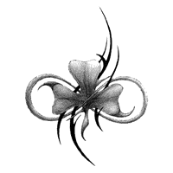
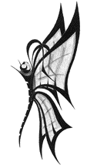

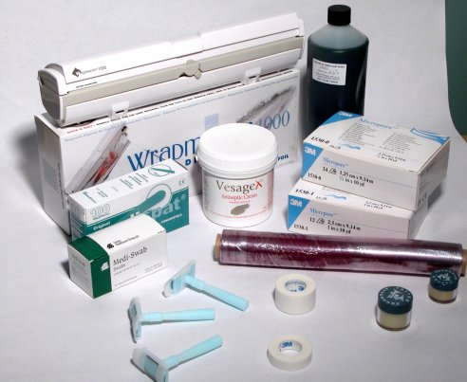

After Tattooing

The required number of pigment capsules in should be placed in the holder, and fill with pigment. Vaseline shall then be placed on the area with spatula or gauze swab. Sterilised needles etc shall then be attached to motors and tattooing can begin.

After Tattooing

All needles shall be discarded into a sharps box for disposal and rods and tubes placed in a designated ‘Dirty’ kidney dish containing detergent. It is recommended that the remains of pigment with capsules are placed directly into a plastic bag lined bin. The tattooed area shall be protected via a gauze covering taped over the area tattooed. All other paper and swabs, tissue etc shall be removed from the treatment area and disposed of immediately. Due to the increased risk of contact with bodily fluids all waste should be treated as clinical waste and suitable arrangements must be made for its disposal.

The motors should be disinfected and all surfaces cleaned down and the pre treatment cleaning and preparation should be carried out.

The ‘dirty’ dish containing used rods and tubes etc must be washed thoroughly with hot
water and detergent. Forceps and capsule holders should also be washed in detergent under hot water.
The needle bars and holders should be cleaned via ultrasound. Then all holders, tubes, forceps, holding tubes and capsule holders should be autoclaved.

After Care

The tattooed area should be covered with sterile non-stick gauze (e.g. Melolin) which is
then taped to the skin; gauze permits ventilation and aids healing. Antibiotic or antiseptic
cream should not be used except under a doctor’s supervision when infection has occurred.
Care advice should be provided to the clients together with an after care leaflet.

Further Information

Further information can be obtained from

The Health and Safety Officer at:

Carlisle City Council

Civic Centre

Rickergate

Carlisle

CA3 8QG

Tel: 01228 817336

Bye Laws relating to: Tattooing

Guidance for Tattooing.

General

Under the Local Government (Miscellaneous Provisions) Act 1982 any person wishing to carry on the business of Tattooing, Ear Piercing, Electrolysis or the practice of Acupuncture needs to be registered with the Local Authority.

Under the above Act the premises, where the business is to be carried out must be registered. This registration will remain in force on the premises providing there is no transfer of ownership of the business.

This guidance note aims to provide information on best practice standards of hygiene and provide information on the facilities required in establishments to ensure compliance with the councils Bye laws made under the above Act. These are designed to secure cleanliness of the registered premises and fittings and persons carrying out the procedure.

Premises

Tattooist’s premises must be clean and be capable of being kept clean. The structure of the premises should be maintained in good repair. All wall coverings should be durable and washable. Floor surfaces should be smooth and impervious and washable.

A wash hand basin with a hot and cold water supply connected into an operational drainage system should be provided in the work room with soap (preferably liquid bactericidal) and an hygienic means of drying hands (disposable and machine auto rolled towels are acceptable).

Work Surfaces

Table tops and other working surfaces should have a smooth impervious surface and be capable of being cleaned and disinfected, Stainless steel or glass are recommended.

Chairs, Seats and Couches.

Chairs, seats or couches should be capable of being regularly washed with hot water and disinfectant. Fabric chairs should not be used. Clients should lie/sit on disposable paper sheeting rather on seating surface.

In addition adequate ventilation and artificial lighting should be provided and maintained throughout the premises. A lighting level of 1,000 lux should be provided in treatment areas and should be free from glare.


