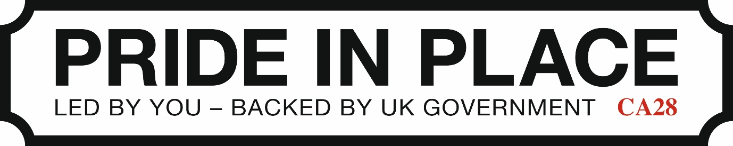

South Whitehaven Neighbourhood Board

Engagement and Communications Plan

July 2026

Date | Version | Amendments | Approved by
05/07/26 | 1 | Draft for Board submission

1. Purpose
This Community Engagement and Communications Plan sets out how residents, businesses, community organisations and stakeholders will be informed, involved and empowered to shape the future of South Whitehaven through the Pride in Place Programme.
The Plan provides a framework for community engagement and communications activity and will support the development and delivery of the South Whitehaven 10 Year Regeneration Plan.
The Plan reflects the Board's commitment to ensuring local people are at the heart of decision-making and that engagement is meaningful, inclusive, transparent and ongoing.

2. Principles
Community engagement and communications activities will be guided by the following principles:
Community-Led: Residents and communities will be central to shaping priorities, plans and investment decisions.
Inclusive and Accessible: Engagement will seek to remove barriers to participation and ensure opportunities are available to people of all ages, backgrounds and circumstances.
Open and Transparent: Communications will be honest and clear about what Pride in Place can and cannot deliver, how decisions are made and how community views are being considered.
Ongoing: Engagement will be continuous throughout the life of the programme and not limited to one-off consultations.
Evidence-Led: Community insight, local knowledge and data will be considered alongside other evidence when informing decisions.
Feedback-Led: The Board will communicate back to communities on what has been heard and how feedback has influenced decisions.
Neutral: The Pride in Place Programme is a community-led programme governed by the South Whitehaven Neighbourhood Board.
Community engagement and communications activity undertaken in relation to the programme will be led, commissioned or approved by the Board and delivered in accordance with this Plan.
No individual Board member, elected representative, political office holder or organisation shall present personal, organisational or political activity as engagement on behalf of the Pride in Place Programme unless expressly authorised by the Board.

3. Objectives
The objectives of this Plan are to:
- Build awareness and understanding of the Pride in Place Programme.
- Enable residents to influence priorities and investment decisions.
- Ensure a wide and diverse range of voices are heard.
- Support meaningful participation from young people and underrepresented groups.
- Maintain ongoing communication with stakeholders and the wider community.
- Build trust and confidence in the programme and the Board.
- Ensure community views are reflected within Board decision-making.

4. Governance and Responsibilities
  - The Neighbourhood Board
The Board will:
- Approve this Plan and any subsequent revisions.
- Set the overall direction for engagement and communications activity.
- Consider engagement findings when making decisions.
- Monitor the effectiveness and reach of engagement activity.
- Ensure engagement remains inclusive, transparent and politically neutral.
  - Community Development Officer
The Community Development Officer will coordinate, commission and oversee community engagement and communications activity on behalf of the Board and in accordance with the direction provided by the Board. Responsibilities will include:
- Coordinating day-to-day engagement activity.
- Developing relationships with residents, community groups and stakeholders.
- Managing engagement programmes and activities.
- Maintaining records of engagement activity and feedback.
- Reporting findings and emerging themes to the Board.
- Supporting community feedback loops.
- Coordinating commissioned engagement activity undertaken by partner organisations.
  - Board Members
Board members are ambassadors for the programme and should actively support engagement and communications activities approved by the Board. Board members shall:
- Promote approved engagement opportunities.
- Encourage participation from communities and stakeholders.
- Support consistent and accurate communications.
- Act in accordance with the Board's Code of Conduct.
Board members are not authorised to undertake formal engagement, consultation or issue communications on behalf of the Board unless specifically authorised to do so.

5. Delivery Approach
The Board recognises that different communities engage in different ways and that a range of approaches may be required throughout the programme.
Engagement may include:
- Community events and drop-in sessions.
- Workshops and focus groups.
- Surveys and questionnaires.
- Digital engagement.
- School and youth engagement.
- Community conversations.
- Neighbourhood-based activities.
- Stakeholder meetings.
- Creative and informal engagement approaches.
Methods will be reviewed and adapted over time to maximise participation and ensure all sections of the community have opportunities to contribute.

6. Commissioned and Partner-Led Engagement
The Board recognises that trusted local organisations are often best placed to engage particular communities and groups. The Board may commission or fund local organisations, community groups, charities, social enterprises or other providers to undertake engagement activity on its behalf.
All commissioned engagement activity must:
- Align with this Plan.
- Remain politically neutral.
- Support inclusive participation.
- Provide evidence and feedback to the Board.
- Comply with relevant safeguarding, equality and data protection requirements.
Commissioned organisations will be expected to demonstrate how community views have been gathered and reported.

7. Communications
The Board will maintain clear, timely and accessible communications with residents and stakeholders.
Communications activity may include:
- Website updates.
- Social media.
- Press releases.
- Community newsletters.
- Public meetings and events.
- Printed materials and notices.
- Direct community updates.
The Chair shall normally act as the principal spokesperson for the Board unless alternative arrangements are agreed.
Board members, elected representatives and partner organisations should avoid communications that:
- Pre-empt Board decisions.
- Misrepresent Board discussions or decisions.
- Create unrealistic expectations regarding funding or delivery.
- Conflict with approved Board communications and plan.
- Compromise public confidence in the programme.

8. Monitoring and Reporting
Engagement activity will be monitored and reported to the Board on a regular basis.
Monitoring will include:
- Participation levels and reach.
- Diversity of participants.
- Geographic coverage across South Whitehaven.
- Key themes emerging from engagement.
- Actions taken in response to community feedback.
- Lessons learned and opportunities for improvement.
The Board will ensure that feedback is shared with the community wherever possible.

9. Review
This Plan is intended to be a live document and will be reviewed at least annually by the South Whitehaven Neighbourhood Board.
Any material amendments must be approved by the Board.

